Table of Contents
Bowl-for-a-Cause Team Contract 3
Who Did What 4
The Planning Phase 5
Critical Path and Risk Assessment 6
Milestones (Work Back Schedule) 6
Emergency Response Plan 9
Sponsorships 10
Event Promotions 11
Execution Phase 12
Agenda 12
Evaluation Phase 14
What Was Done Well? 14
Unexpected Situations 14
What We’d Do Differently 16
Appendices 18

Bowl-for-a-Cause Team Contract

Team 5, Bowl-for-a-Cause wishes to raise money and bring awareness to Reception House Waterloo Region, a charity that helps government-assisted refugees.

Code of Conduct

Each team member is expected to abide by the following:
- Be respectful towards each other
- Attend scheduled meetings on time
- Notify team members in advance if unable to attend meetings
- Meet assigned deadlines on time
- Seek help if needed

Communication

Communications run primarily through Messenger.com. New updates or issues are immediately passed to the rest of the team while deadlines (as outlined in the Workback Schedule) are discussed as needed. Team members are expected to respond within 24 hours and keep up with communications.

Decision-Making

Decisions are brought to the rest of the team and discussed to determine the best course of action based on a thorough evaluation of that decision. Disagreements over a decision are discussed reasonably until members can determine the best course of action for the entire project.

Performance and Conflict Resolution

Violators of this contract are to attend a team meeting. The necessary apologies and recognition of mistakes are to be made before the team can move forward.

Signatures and Contact Information

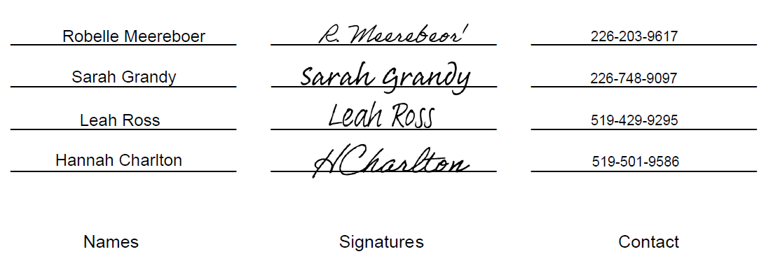

Who Did What
Robelle
- Organized and completed the budget (see Appendix J 1-3)
- Organized and kept track of all documents that needed to be submitted
- Secured Canadian Tire oil change certificates, maple syrup, honey and candles for the raffle
Sarah
- Created the “bowling party” idea
- Social media writer
- Created and designed our event website
- Secured lash extensions, YMCA gym membership, one of two hair salon certificates, laundry detergent, and the blanket in the Canadian themed gift basket
Hannah
- Point of contact with Lisa Bucking from Bingemans
- Created and printed the sponsorship packages and the sponsorship thank-you board
- Secured Waterloo Brewing and Tupperware donation
Leah
- Point of contact with Kathie Must
- Collected ticket sales money via e-transfer
- Designed event logo and poster
- Secured the Body Shop basket, lottery tickets, one of two hair salon gift certificates, the painting and frame, Norwex package, Scentsy gifts, and the Coffee mug

The Planning Phase
At the start of the project, all four of us had some ideas that we thought would work well for our event, including an art gallery display with a silent auction or a masquerade ball. The group decided to not follow through with art gallery idea because we could not think of a reason why artists would give us their art pieces for free and not get paid for each item sold.
We wanted to get approval for a masquerade ball but it got rejected because there were so many elements that had to go into planning one, and as soon as we heard about Reception House planning a gala in June, we knew it would not be a good idea.
However, after some consideration, Sarah came up with the idea of a bowling event. It was a simple idea that would have secured the possibility to meet the goals set by Kathie, Patricia and Dave.
Since K-W offered a few different bowling alleys, we decided to compare them to see which one offered best suited our event. We also wanted one that wasn’t overly expensive and had the capacity for a large group of people. We visited iBowl, Towne Bowl and Brunswick Bowl. These venues had some potential, however, there were major concerns about the small parking lots, lack of permits, bringing a third-party caterer, and rental fees.
The group was having a hard time deciding what the fourth option was until someone said, “too bad we can’t get Bingemans.” Five minutes later we sent an email to Lisa Bucking, the event planner at Bingemans. Within a week’s time we had secured Bingemans as our venue.
Bingemans was the better choice to go with because not only did it have the ability to hold a large number of people, but also offered a large parking lot, it came with decor, and they offered us 10 per cent of total food costs, ordered by our guests.
Bingemans has one large room that holds a bar, 20 lanes, a dining area for Boston Pizza, billiard tables, and a room upstairs called the “Strike Zone”. It also has a small private eight-lane room with a small bar where guests can order drinks and food from Boston Pizza. We decided that going with the eight lanes instead of the 20 lanes would be better for our event because it would feel more intimate and exclusive in the smaller room, and it would be easier to fill eight lanes instead of 20.
We also thought that the smaller room would interfere less with Bingemans’ business. The venue came with its own liquor license and raffle permits. Overall, this venue was the best option and suited our event perfectly.

Critical Path and Risk Assessment

Milestones (Work Back Schedule)
Organization played a huge role in running our event, Bowl-for-a-cause. The use of a work-back schedule kept our group very organized and on track. The group always knew what had been done, what needs to be done, and who is responsible for what. Trello was a great resource for creating our work-back schedule and achieving all the milestones successfully.
Below is an our work-back schedule in chronological order:
5+ weeks before (Feb. to March 3):
- Confirm venue
- Get website live
- Start posting on social media (Facebook)
- Create sponsorship packages
4 weeks before (March 4 to 10):
- Figure out how to collect funds
- Continue to post on social media (Facebook)
3 weeks before (March 11 to 17):
- Create emergency response plan
- Sign venue contract
- Continue to post on social media (Facebook)
2 weeks before (March 18 to 24):
- Pay venue 25% deposit
- Collect sponsors for lanes
- Continue to post on social media (Facebook)

1 week before (March 25 to 31):
- Collect prizes for raffle
- Continue to post on social media (Facebook)
3 days before (April 1 to 4):
- Create sponsor logos for display
- Register teams (ongoing)
- Finalize number of teams
- Finalize number of volunteers and their roles
- Continue to post on social media (Facebook)
One day before (March 5):
- Second last social media post (Facebook)
- Finalize prizes
- Create Reception House information board
- Finalize budget
- Create “thank you to our sponsors” board
- Finalize number of sponsors
- Have two floats ready for if guests need change
- Make sure guests are aware of “no refund” policy
Day of event (April 6):
- Set up at venue
- Set up raffle table
- Set up Reception House info table
- Discuss duties with volunteer
- Last post on social media
- Welcome guests
- Assign lanes to guests
After event:
- Pay difference for venue
- Send food receipts to Boston Pizza’s head office
- Final written report

Emergency Response Plan
As mentioned previously, our group used a work-back schedule to keep everyone on track. In addition to this, we held regular team meetings to make sure everyone was organized and on the same page (see Appendix A 1-10). We were fortunate to have a venue that had all required permits and safety documents on site. We were able to rely on Bingemans to have emergency equipment and/or documentation (see Bingemans contract Appendix B). Organization, teamwork and planning ensured we did not encounter any emergency events. Of course, things didn’t go as planned, which we will explain later in this document.
At the event, one thing that came close to an emergency was our microphone did not work when the time came to use it. This is where our contingency planning came into play. We had already discussed the things that could go wrong weeks before; the day of the event we were prepared.
We determined that Leah and Robelle have the loudest voices, so they would take the place of our broken microphone and call out the prizes and winners, as well as make any announcements.
Another part of our contingency plan was “what if it’s too loud for guests to hear us call out the prizes?” For this possible issue, we came up with a couple solutions:
- Ask the bartenders to turn down the music
- Close the doors on each end of the event room
- Use the room available upstairs specifically for the raffle part of the event (spoke with manager prior to event about this)
Inclement snowy weather began late afternoon on the day of our event.
We also had a road closure due to construction. We handled this situation by reminding guests to give themselves some extra time via our Facebook page. Additionally, as guests were leaving, we kept a lookout on weather conditions and ensured that they were aware and prepared to drive home carefully and safely. We also wished them well as they left for the night.

Sponsorships
During our search for sponsorships and donations, we approached many different businesses in the KW area. In the beginning stages, it seemed slow as we only had a few confirmed prizes from some family members and friends. Robelle, Sarah and Hannah all had leads with family members or friends that could donate something. Leah posted on a Facebook Buy and Sell page, inquiring about where to look for donations, and the outpour of generosity was incredible. Through that post, Leah was connected with people that ended up donating amazing prizes for the raffle.
We were unsuccessful with a few leads; sometimes the business was not able to donate or they simply didn’t respond. We reached out to McDonald’s, Toyota and GNC, and we did not receive anything from them. However, the donations we did receive were fantastic.
We were donated:
- Large gift basket from the Body Shop in Fairview Park Mall
- Beer taster/beer glass gift from Waterloo Brewing Company
- 3-month family gym membership to the YMCA in Kitchener
- Full set of eyelash extensions from a local stylist at Always Lashed
- Coffee mug with a handmade “Canadian, eh?” design
- Body wash and bath bomb from a local Scentsy representative
- Tupperware gift set from a local Tupperware consultant
- Homemade maple syrup from Robelle’s boyfriend’s family
- Wash, cut, and blow-dry from Lainy’s Locks, a local stylist
- Cut and style from UpTown Beauty Lounge in Waterloo
- Homemade honey and beeswax candles from Robelle’s friends
- $100 worth of lottery tickets from the Catholic Charities Lottery
- Norwex cleaning supplies bag from Julie Hause
- 2 oil change certificates and a tub of laundry detergent from Canadian Tire
- Handmade watercolour painting from an old neighboor of Leah’s
Our correspondent channels varied, depending on who we were connecting with. For example, a simple text, phone call or in person conversation was made if we knew the person personally, otherwise conversations usually happened via email or Facebook messenger. In total, we raised $986.50 and after paying the expenses, we donated a total of $575.52 to Reception House Waterloo Region (see Appendix J 1-3).

Event Promotions
We began promoting our event more than five weeks prior. We created an event website using weebly.com; as well as posts on Facebook. Sarah was responsible for posting on Facebook, but the other team members shared the event posts to their Facebook friends, which created more awareness about the event (see Appendix C 1-9).
The group updated the website and Facebook page frequently/as needed. We included photos and persuasive language to entice people to attend. We encouraged all guests to register their team on our website, and gave guests the option of prepaying through e-transfer to Leah, or paying at the door upon arrival. We informed guests that the admission fee was raised if they paid at the door.
We worked as a team to gather participants, but because each team member did not know every guest, Bingemans kindly provided us with wristbands for each guest, so we could keep track of who paid to be at our event.
We created attractive sponsorship packages, which were given to all potential sponsors (see Appendix D). In return, we had one lane sponsored; raised close to $1000; and received more than 20 donated raffle prizes. We created a Thank You to Our Sponsors board, which included all the logos of the companies that sponsored a lane or donated money or a prize (see Appendix E). This helped us express our gratitude, while also raising awareness and promoting each company. We also wrote and delivered thank-you cards with our own personal cards and a thank-you card given to us by Reception House. For the people that we only connected with through email or Facebook, a digital thank-you card was created and sent to them (see Appendix F).

Execution Phase

Agenda
On the day of the event, the Bowl-for-a-Cause team arrived at Bingemans roughly two hours before the event to set up. The event ran from 7 p.m. to 10:30 p.m. We started by doing a walk-through of the event room and positioned each table so that guests had enough space to walk around without feeling crowded.
We started with the entrance. This is the area where the bar was located and the area with the most amount of space. We decided this would be the best area for the raffles. Bingemans gave us access to three buffet size tables with table cloths, and two easels to position our sponsorship board and our painting raffle prize (see Bingemans contract Appendix B).
With the raffles positioned at the entrance, the prizes, bows and ribbons immediately caught the eyes of each guest, as well as those passing by. We wanted our guests to participate in the raffles so that we could raise as much money as possible. We felt that having the raffles positioned as the first thing guests saw when they walked in was the best way to do so.
We also felt that if other visitors who were not participating in our event walked by and saw the raffles, it would create curiosity and they would also want to participate in the raffles, which meant more monies raised.
Next, we assigned each team mate and our volunteer, Phoebe, with duties. Leah was in charge of the gumball contest, as well as the Reception House information table. Sarah was in charge of the raffle table, with help from our volunteer (see Appendix G 1-2). Hannah and Robelle were in charge of checking guests in as they arrive, taking payments, guiding visitors in the right direction to the event, and assigning lanes. Once all the guests had arrived and were checked in, we all helped each other in our roles so that each member could walk around and interact with guests (see Appendix H 1-5).

Evaluation Phase

What Was Done Well?
Since the beginning, the stress was high. Throughout the planning process, we kept our heads together, communicated, remembered all the little things early and we met more often in the early stages and made sure everyone had a part in the planning stages and during the event. We each had our roles to play, however if help was needed, we did not have to look far for it. We were very flexible and understanding with how different everyone’s schedules were. When there was criticism, we listened and used it to better our strategy and way of thinking. Since we kept on top of things like; signage, stationary, bags, first aid etc, we did not have to worry about forgetting things on event day. We were early enough to arrive at the venue to make any late minute trips to pick stuff up, aim lights, and meet with our volunteer. Since the beginning, we had the means to be prepared with every scenario we could think of and in the end the event went as smooth as possible.

Unexpected Situations
- Microphone
Since our event took place in a noisy atmosphere, our group required a microphone to announce the raffle winners. Sarah brought a mini stereo and mic from home, but when the time came to use it, it decided not to work. Thanks to our contingency planning, we avoided a major problem. As previously mentioned, we decided that Leah and Robelle were able to speak the loudest, so they would take the place of our broken microphone and call out the prizes and winners, as well as make any announcements. We asked the bartenders to turn the music down so that guests could hear them yell a bit better.
- Guests who couldn’t make it
The next unexpected situation was when guests who previously paid for a lane, couldn’t make it. This was only an issue for one lane. A team of five prepaid for their lane, but the night of the event they were unable to make it. We considered posting on social media that we had a lane open, but we decided to keep the lane available for any guests walking through the event that wanted to participate.
The team that prepaid knew there were no refunds, which ensured we did not lose any money.
- Guests not knowing where event room was
The venue was very large. We noticed some of our guests were getting confused as to which room the event was taking place. A few guests wondered off into the main bowling area. We then decided that since there were two team members checking each guest in, that one of them could escort the guests to the event room. In addition, we decided to change the positioning of our event signs/directional signs (see Appendix I 1-5). The signs had areas and our event name on it, and once we repositioned them, guests were no longer getting confused.
- Needed another prize sign
During set-up, we realized we were short a few name tags for the prizes. Robelle kindly offered to run back out to the dollar store to grab more, and since we were two hours early, this did not cause an issue for the start of the event.

- Dark room
Also during set-up, we noticed the lighting in the room was not very bright. It was difficult to see the raffle table prizes, and the Reception House information board. As a team, we first agreed on the positioning of each table, and then brainstormed a way to make it brighter. We spoke with the very helpful staff at Bingemans, and they kindly agreed to turn the lights facing each table. Crisis avoided.

What We’d Do Differently
We initially booked the 8-lane private room because we were unsure of our capabilities as event planners. We underestimated our friends and family, and we ended up selling out all the lanes and having to turn down anybody else that wanted to participate. If we would have known that, we either could have booked 10-20 lanes in the main bowling alley of Bingemans, or we could have split a bigger group of teams into two sections and booked each section at a different time in the 8-lane room.
If we had done that, we would have made the event longer (to accommodate more people playing) and we would have had to move our raffle tables in the spare room available to us, so transitions between sections would not be crowded.
Also, in that situation, we would have had to expand our social media postings to beyond our own personal friends. We were fortunate that we knew every person attending the event, whether through friends or family however if we expanded the event and filled more lanes, we might have had some people we didn’t know. We would reach outsiders by using Twitter and Instagram as well as Facebook, and we would post on public forums rather than just in our own friend groups.
The last thing we would do differently is to take more photos of people having fun. We took lots of photos of our raffle table, and teams posing for the camera, but not really any action shots. Having a variety of photos is not only beneficial for compiling in a presentation or report, but also to commemorate our hard work.

Appendices
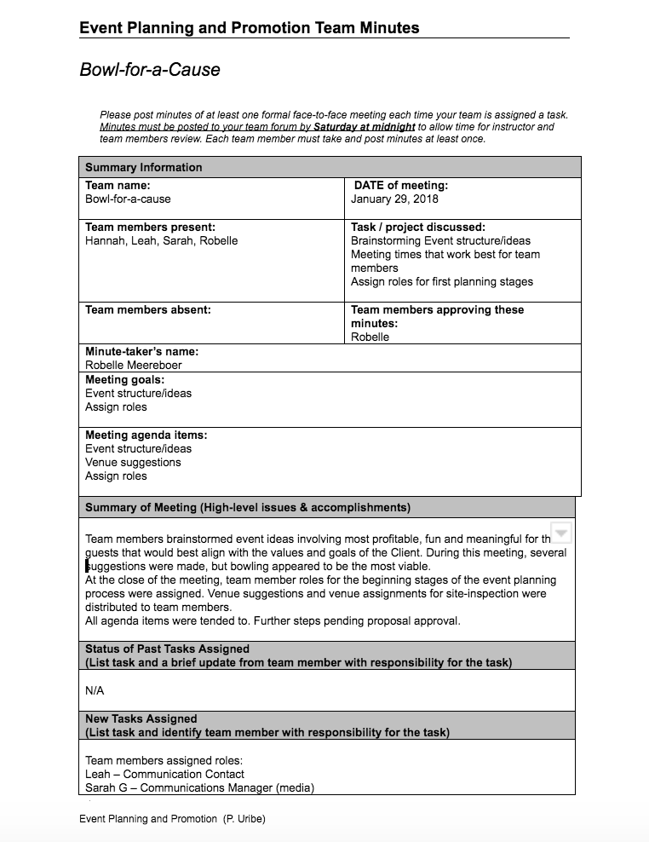
Appendix A 1
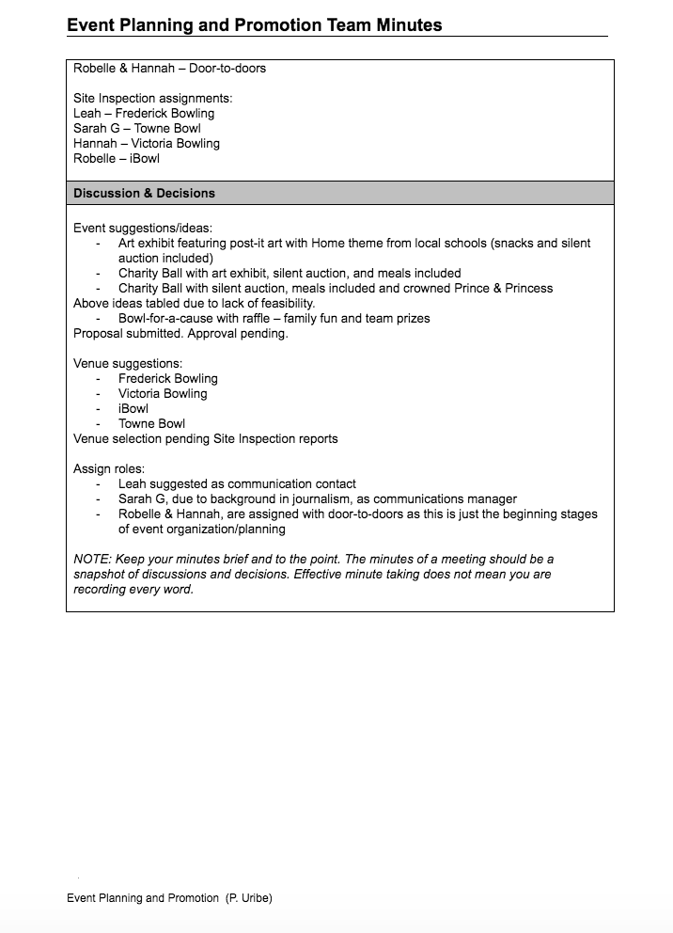
Appendix A 1

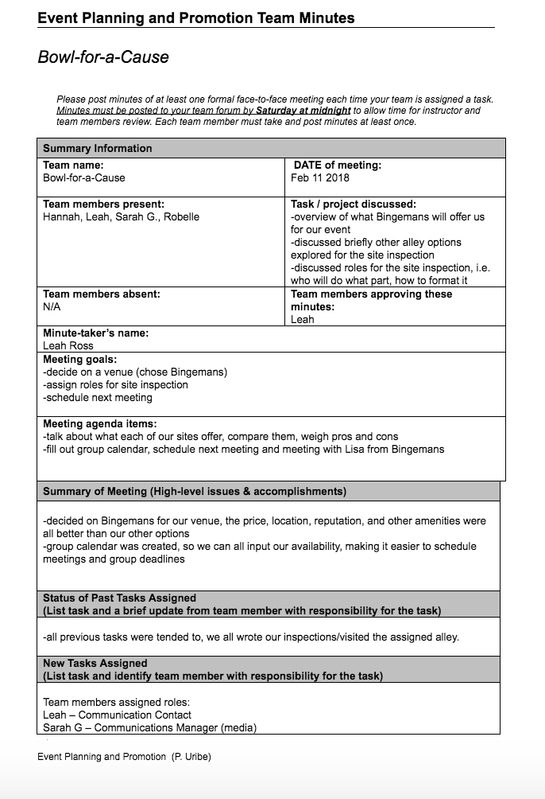
Appendix A 2
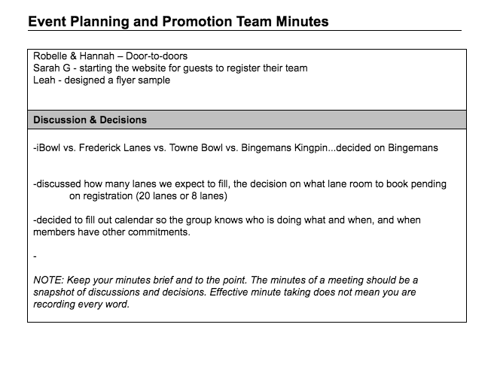
Appendix A 2
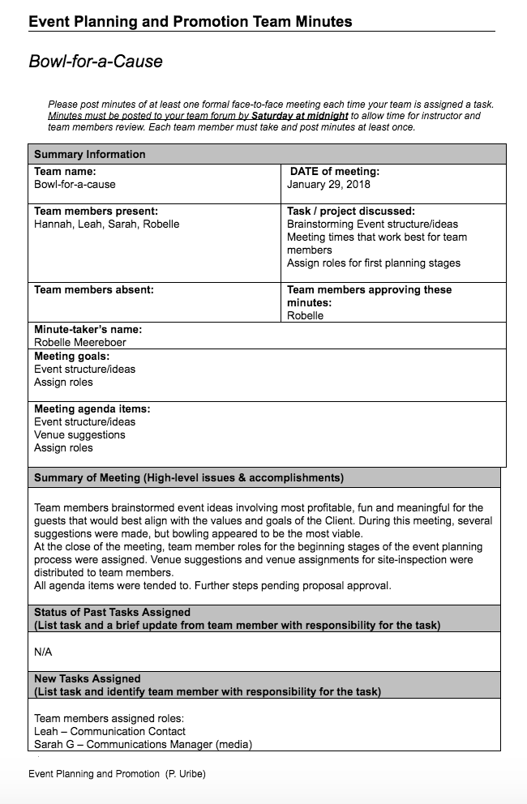
Appendix A 3
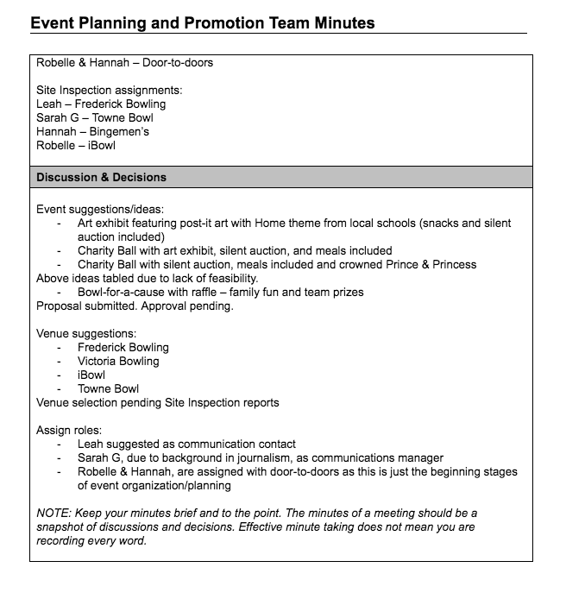
Appendix A 3
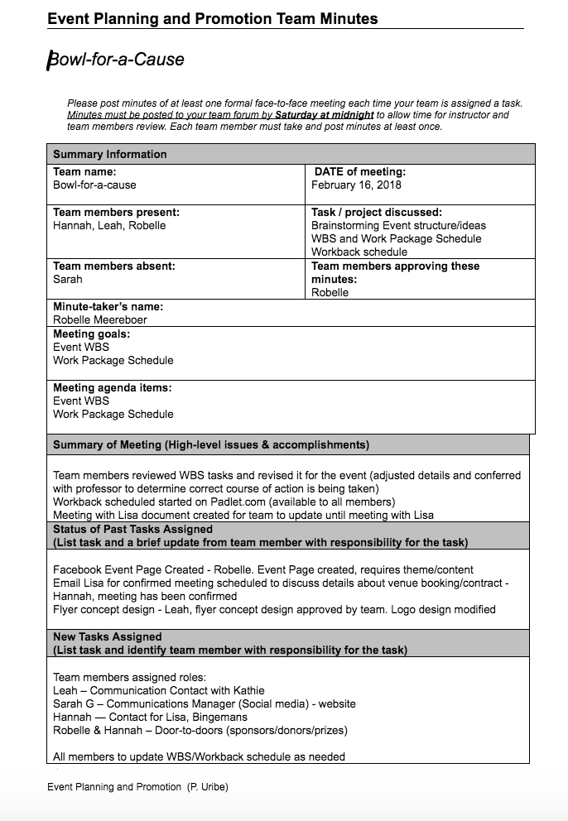
Appendix A 4
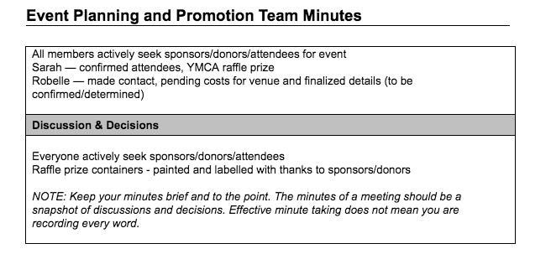
Appendix A 4
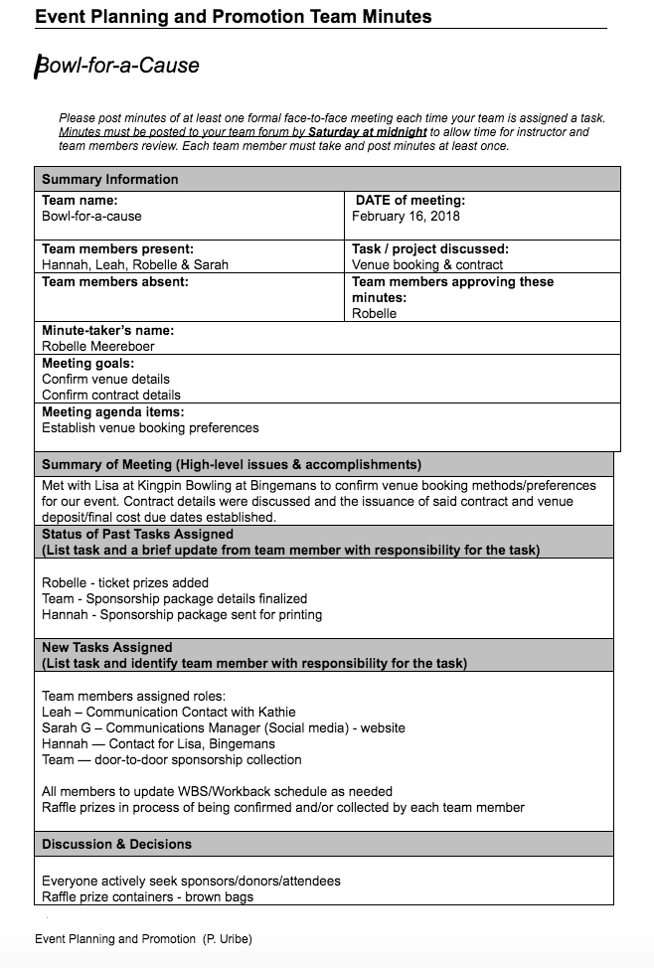
Appendix A 5
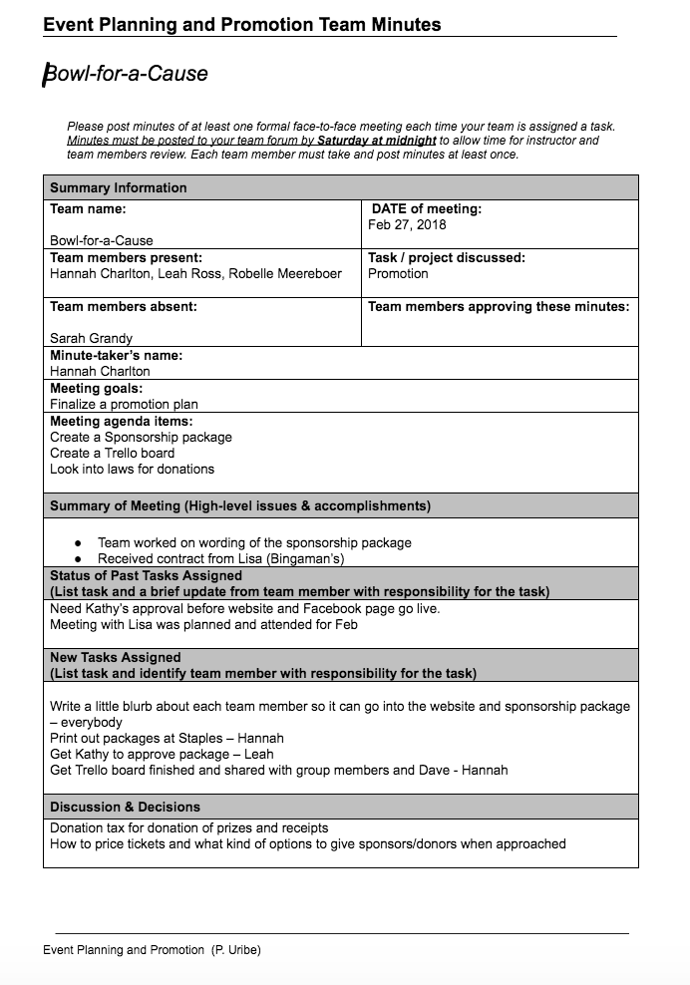
Appendix A 6
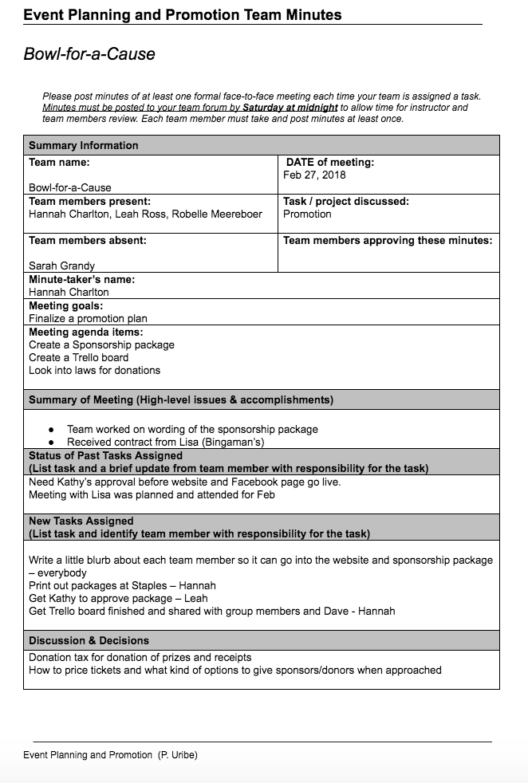
Appendix A 7
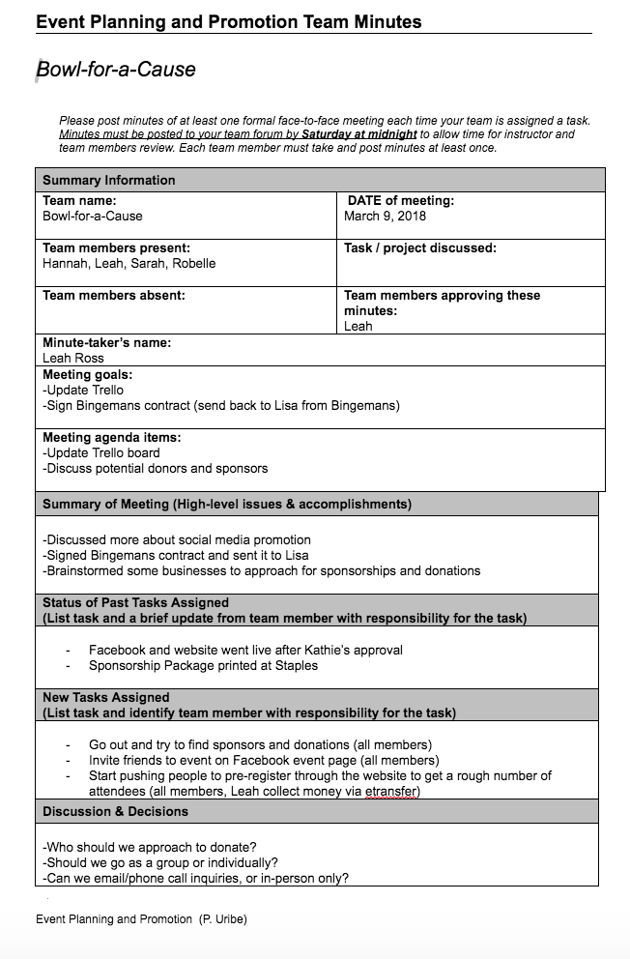
Appendix A 8
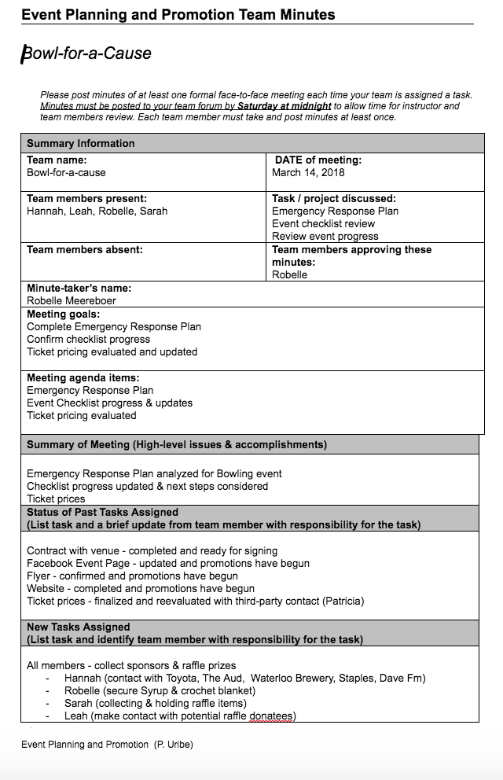
Appendix A 9
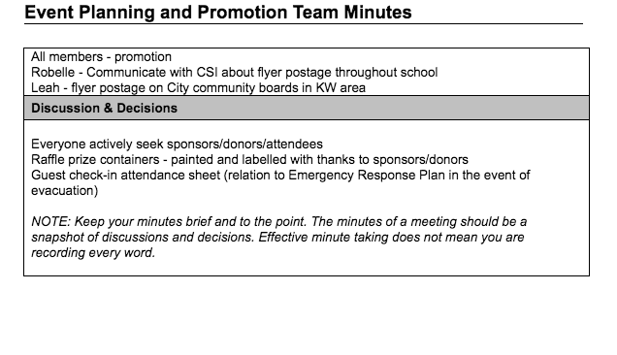
Appendix A 9
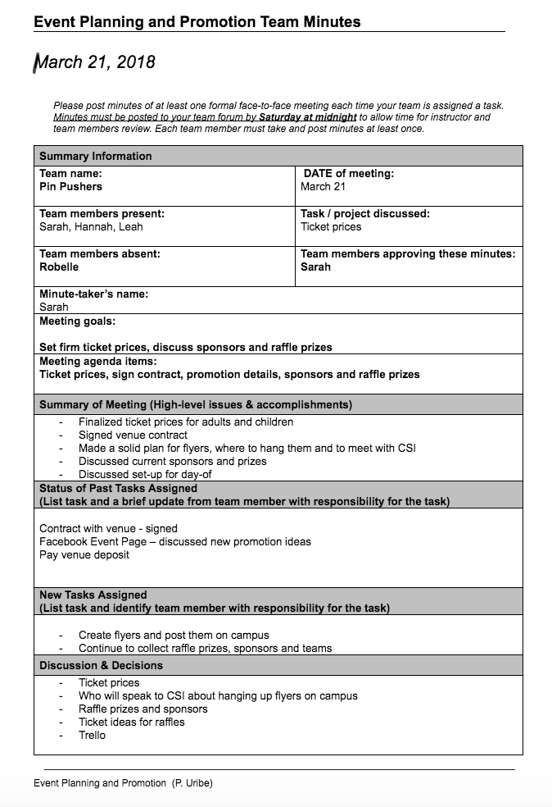
Appendix A 10

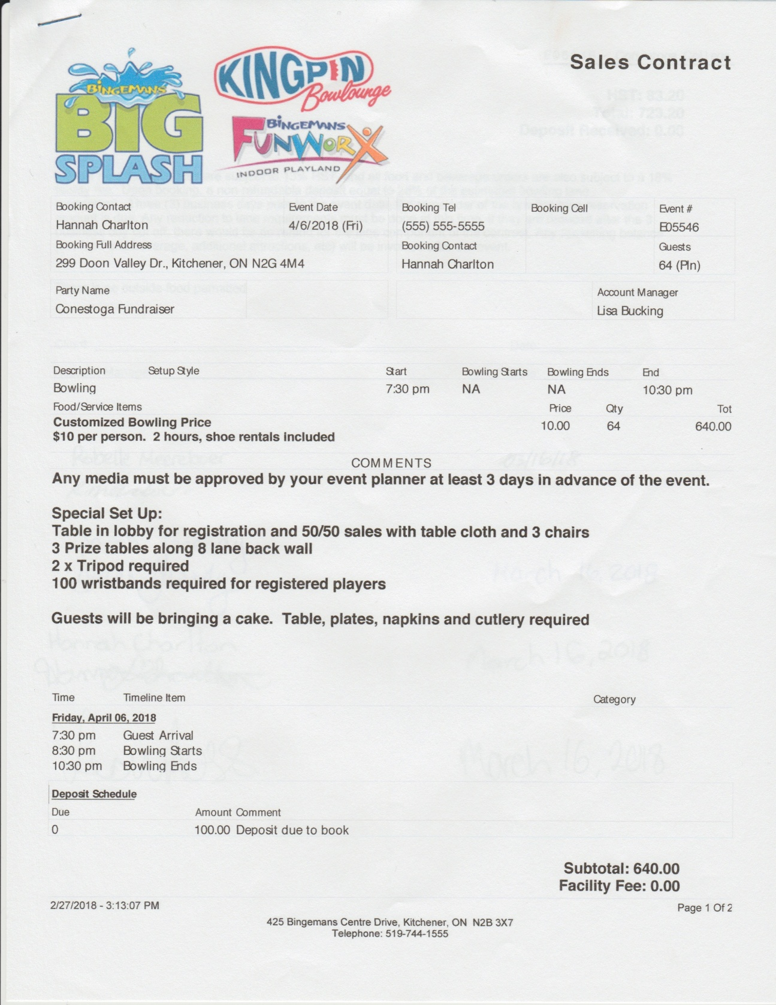
Appendix B 1
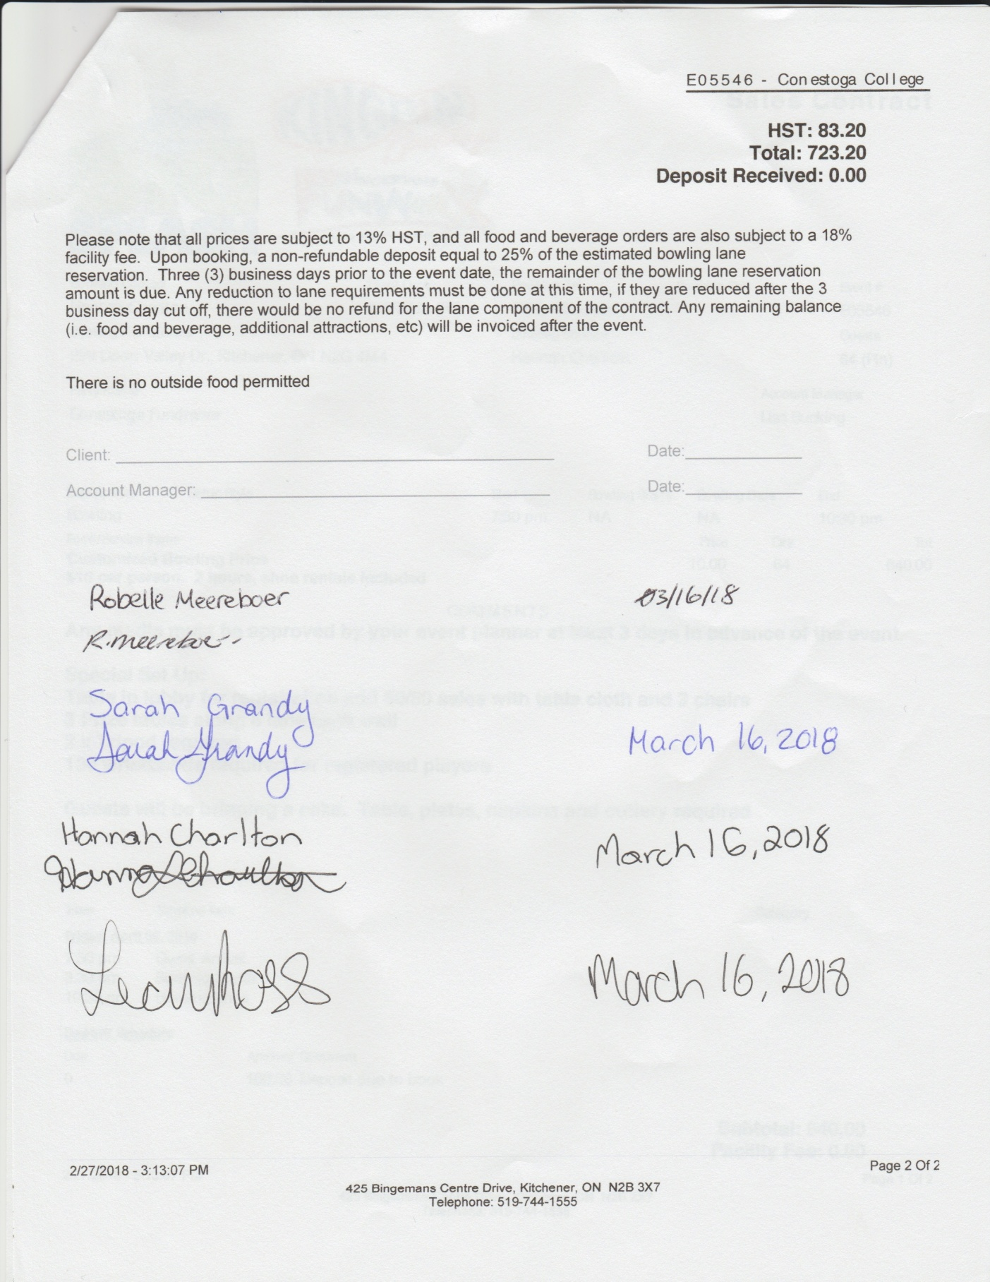
Appendix B 1
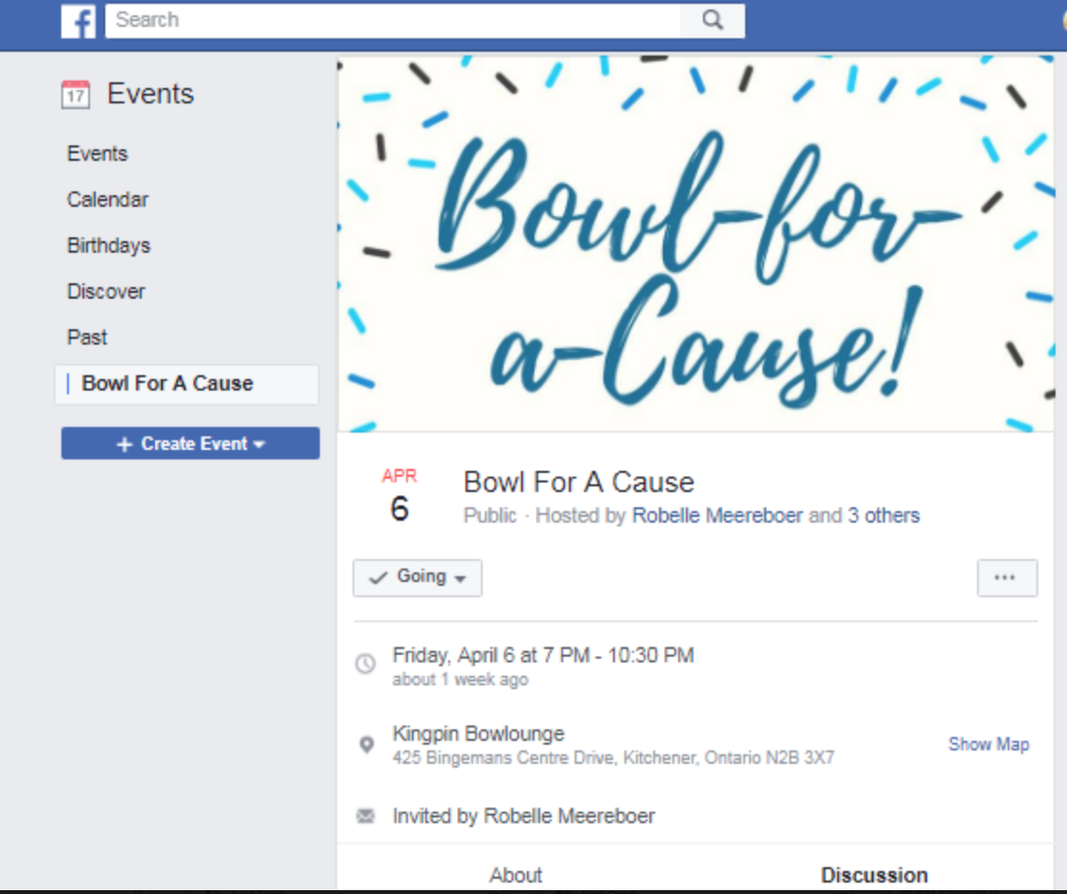
Appendix C 1

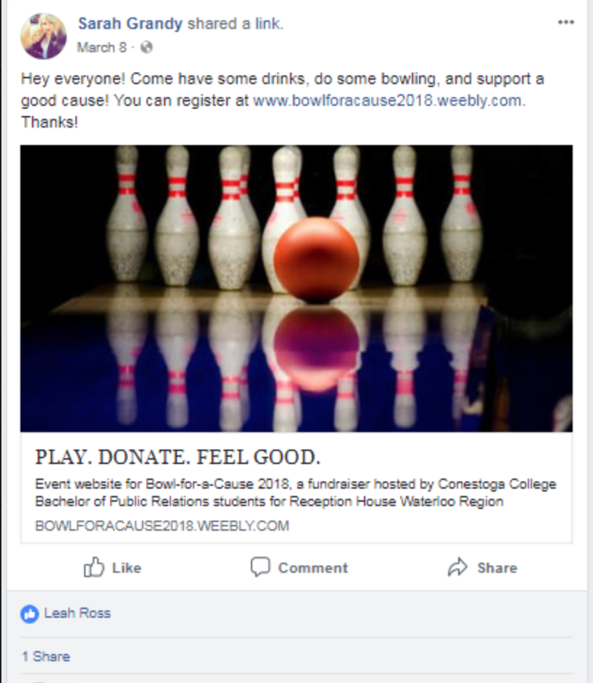

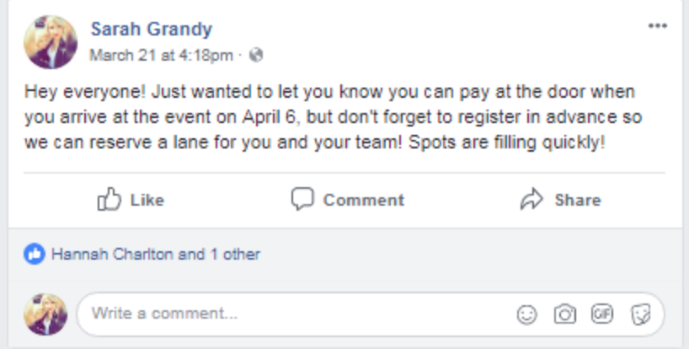
Appendix C 2

Appendix C 3
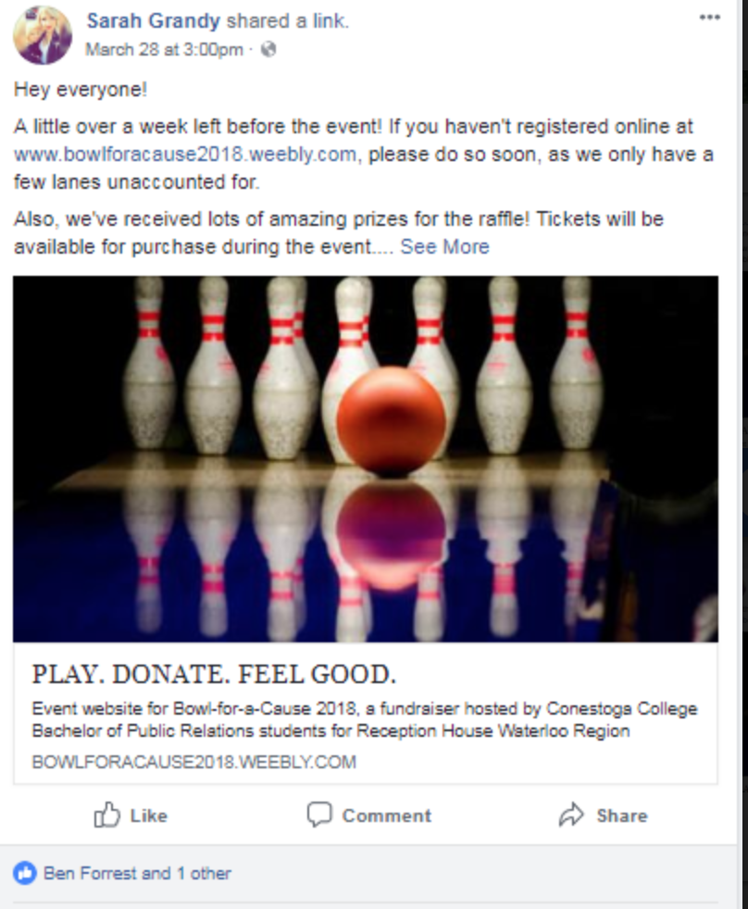
Appendix C 4
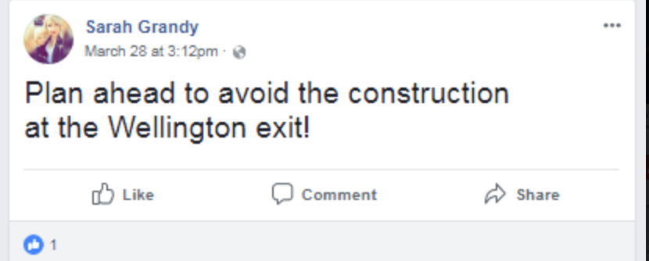
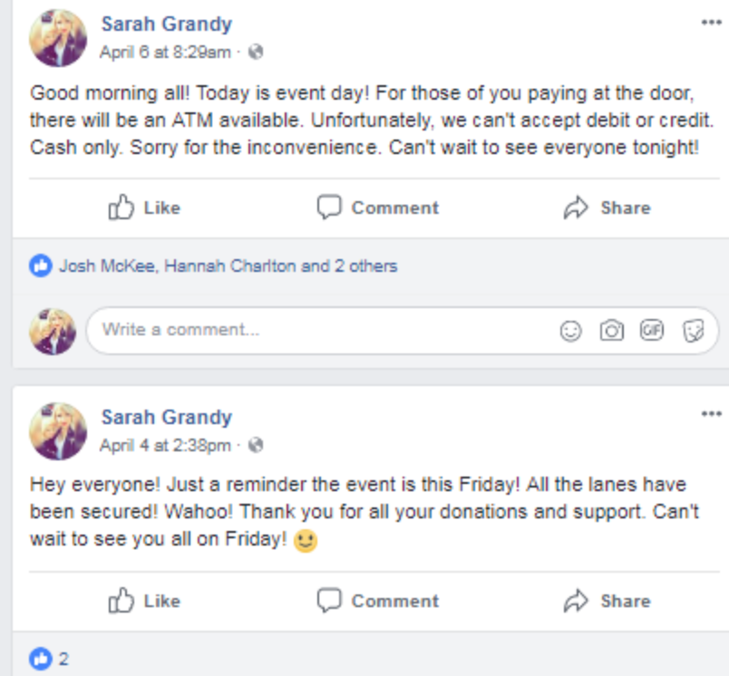
Appendix C 5

Appendix C 6
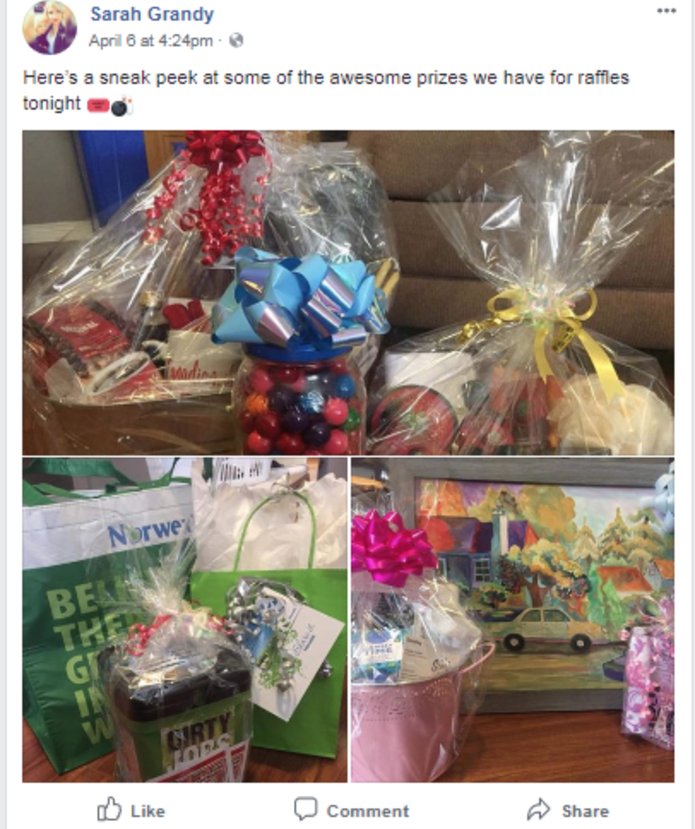
Appendix C 7

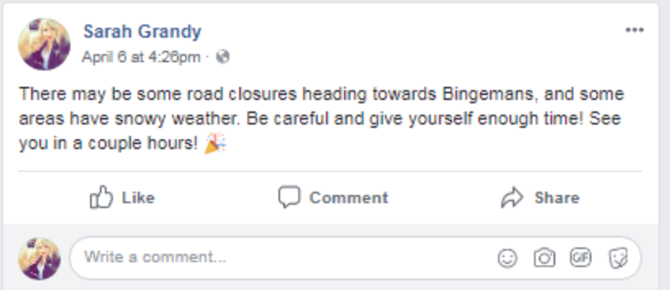
Appendix C 8

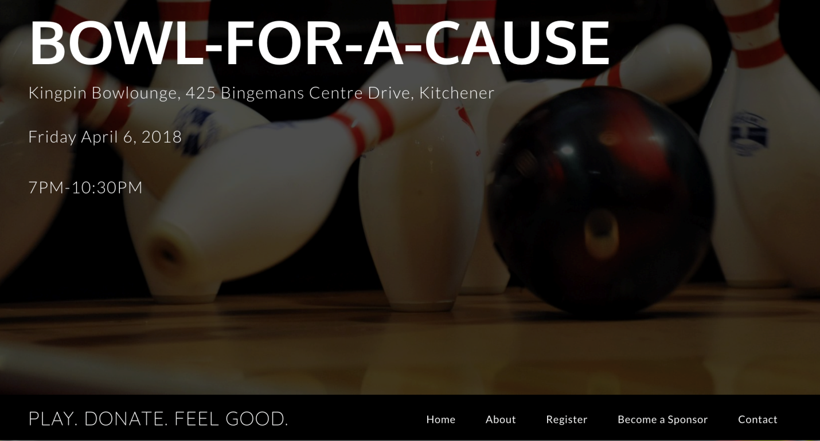
Appendix C 9

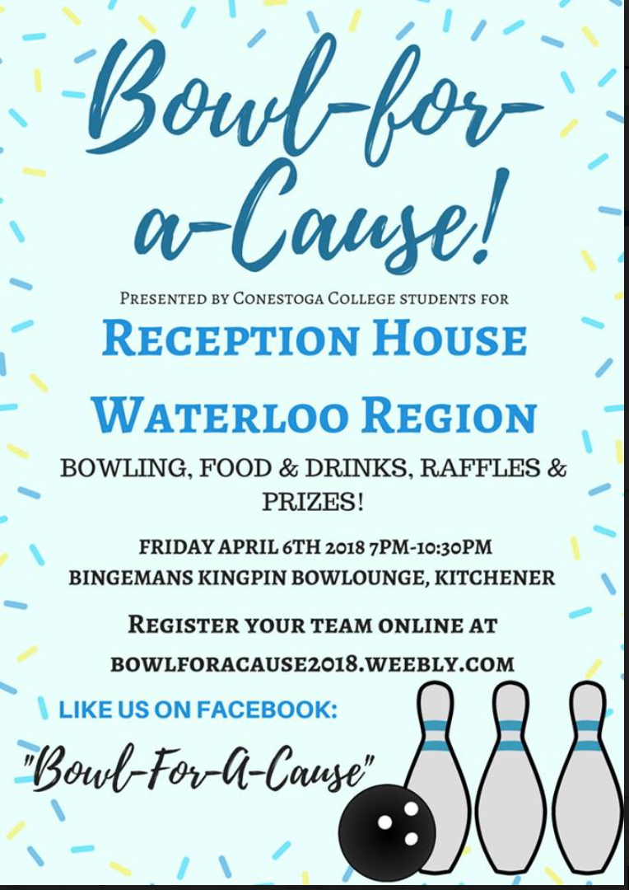
Appendix D

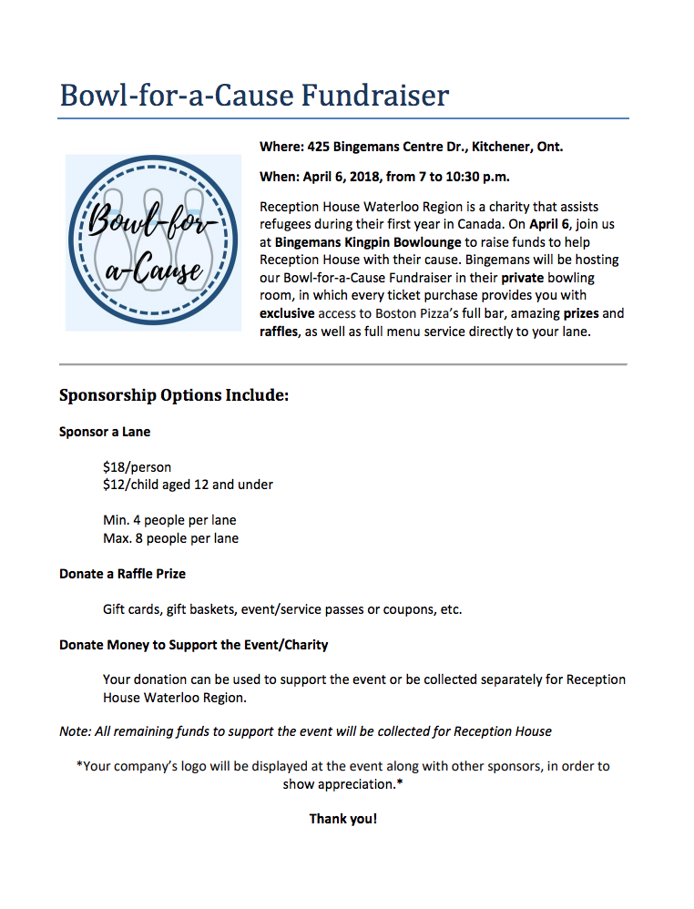
Appendix D

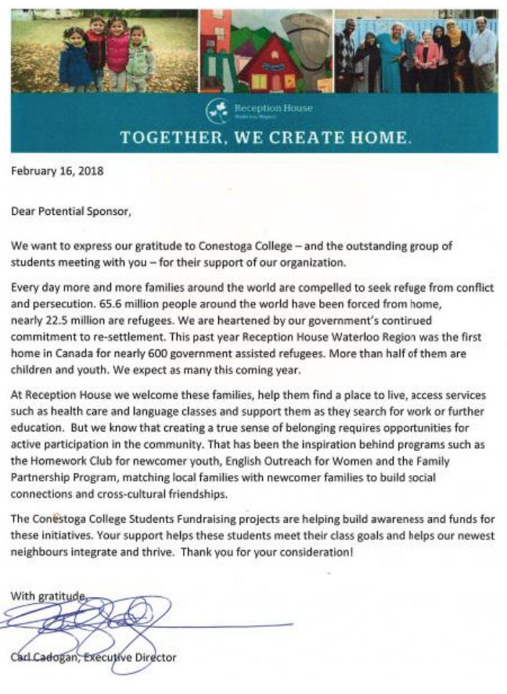
Appendix D
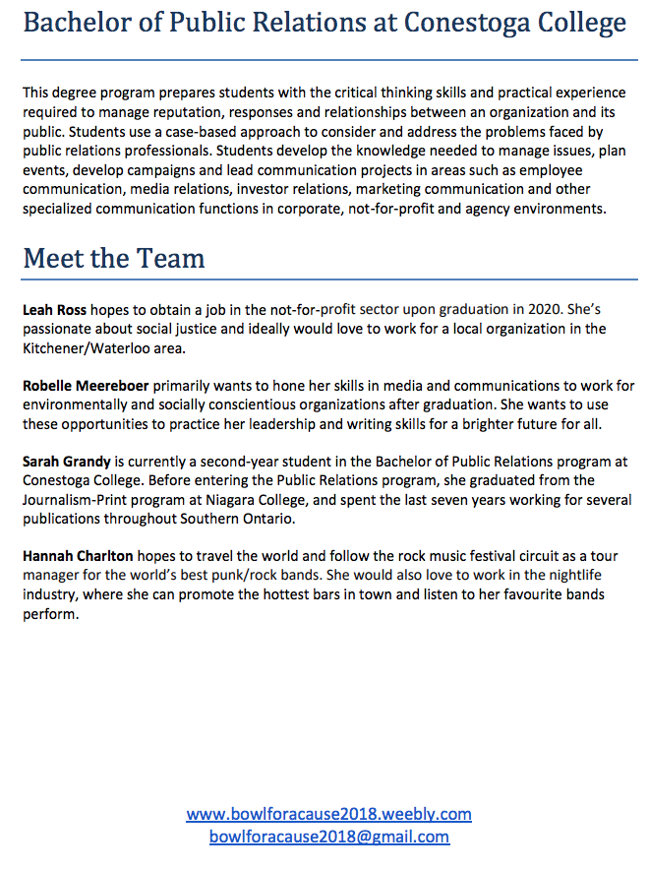
Appendix D
Appendix E

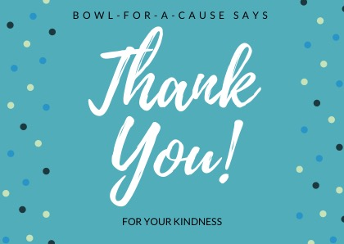
Appendix F
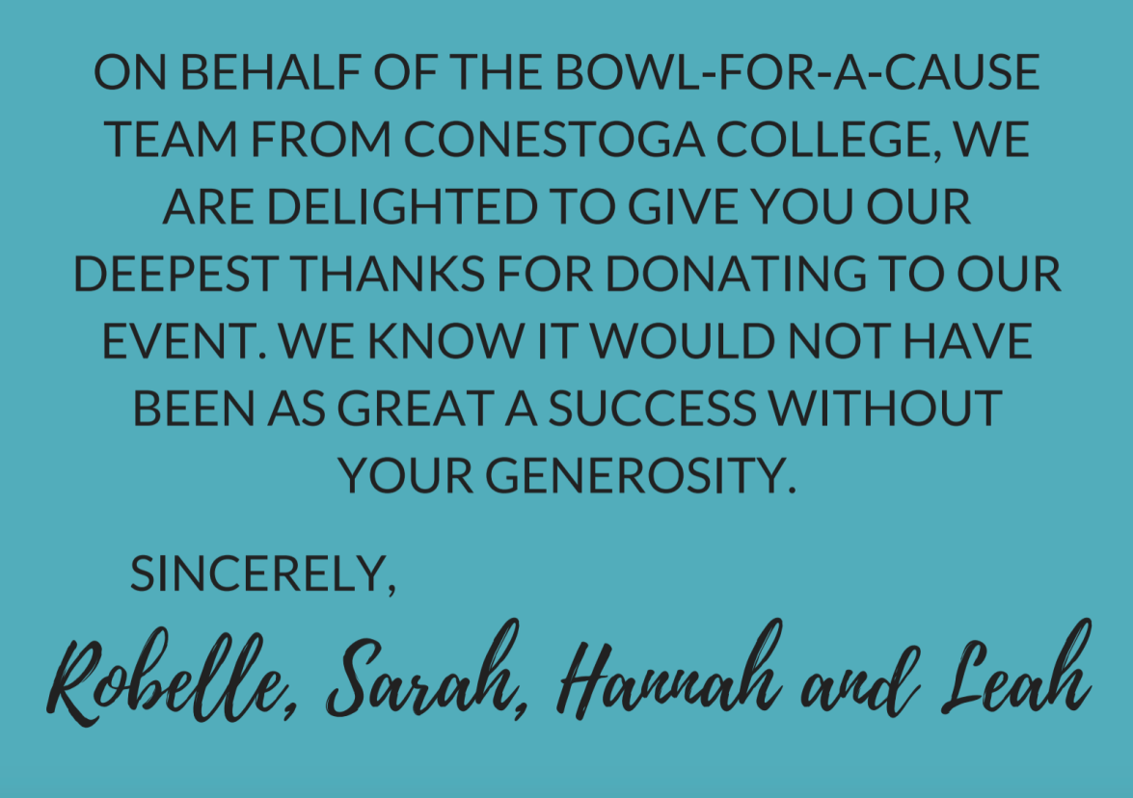

Appendix F

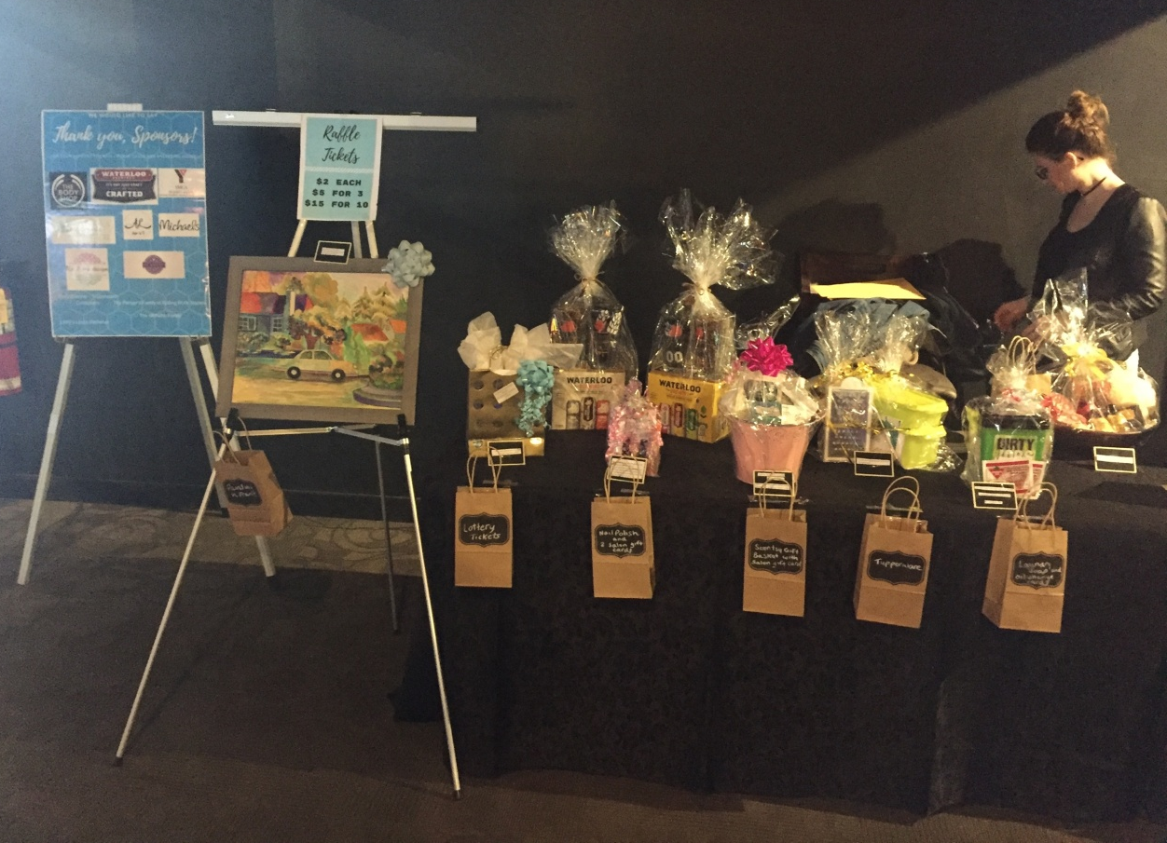

Appendix G 1
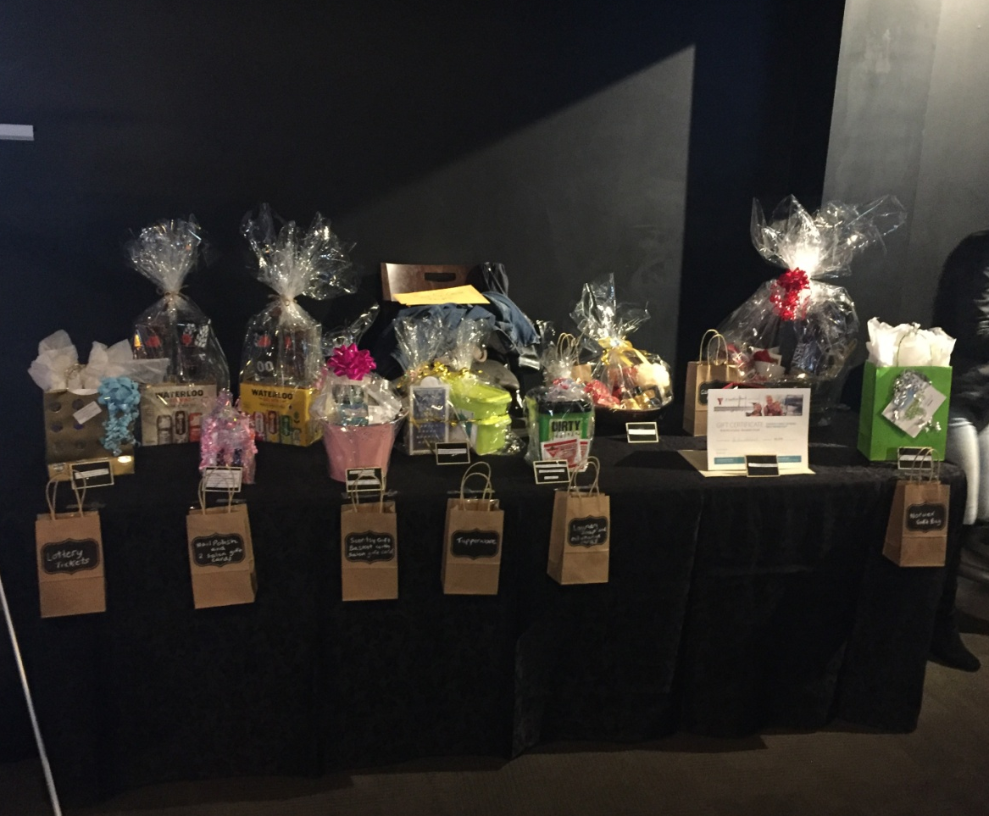

Appendix G 2
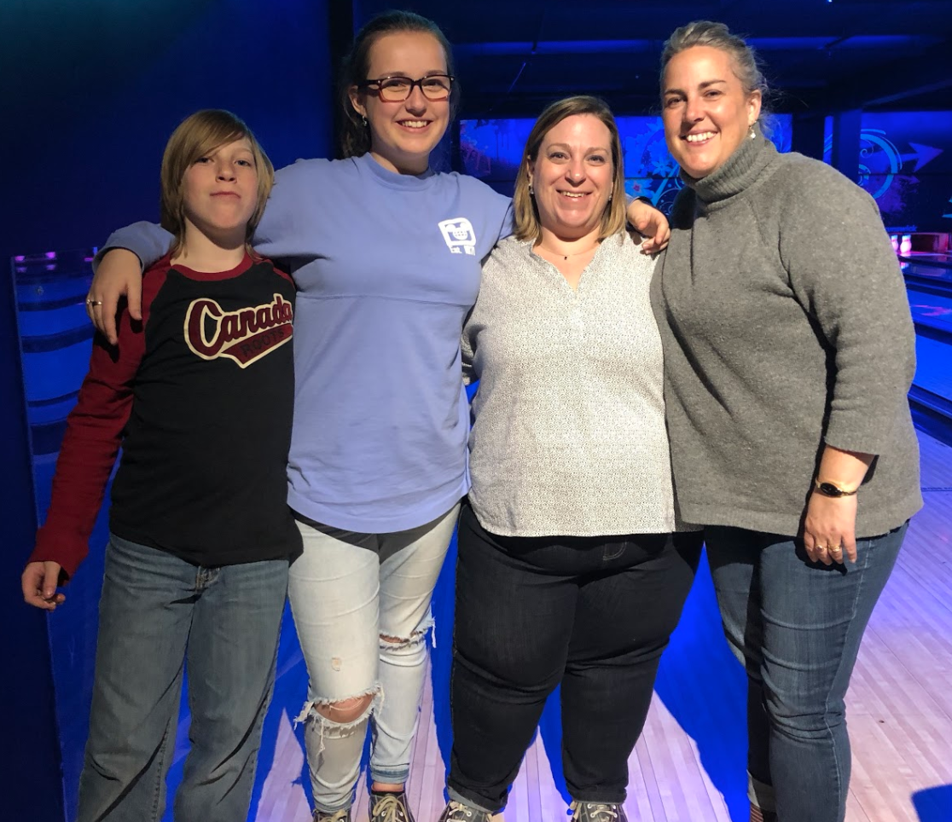

Appendix H 1
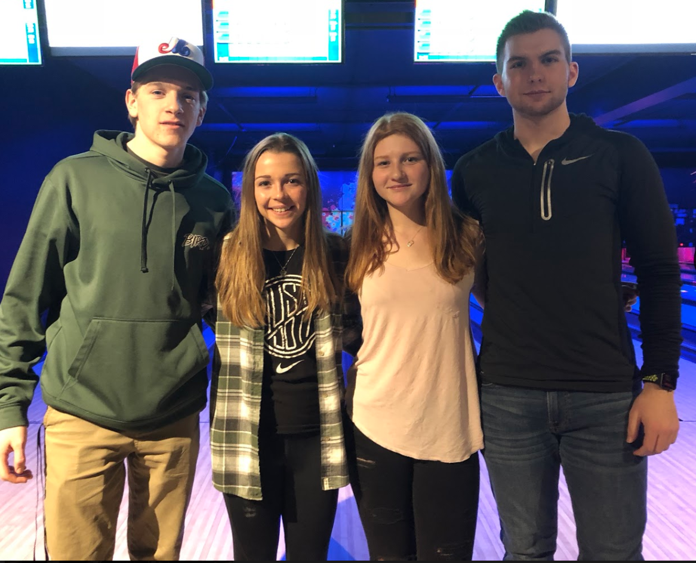

Appendix H 2
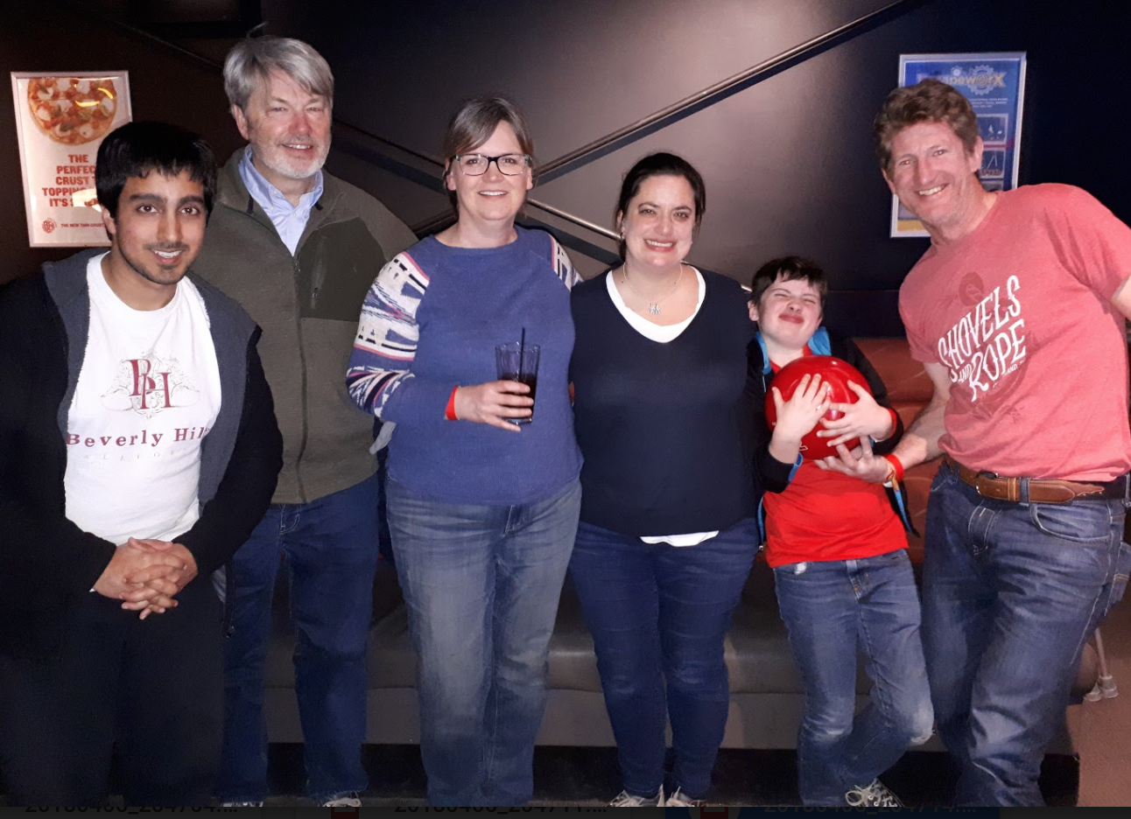

Appendix H 3

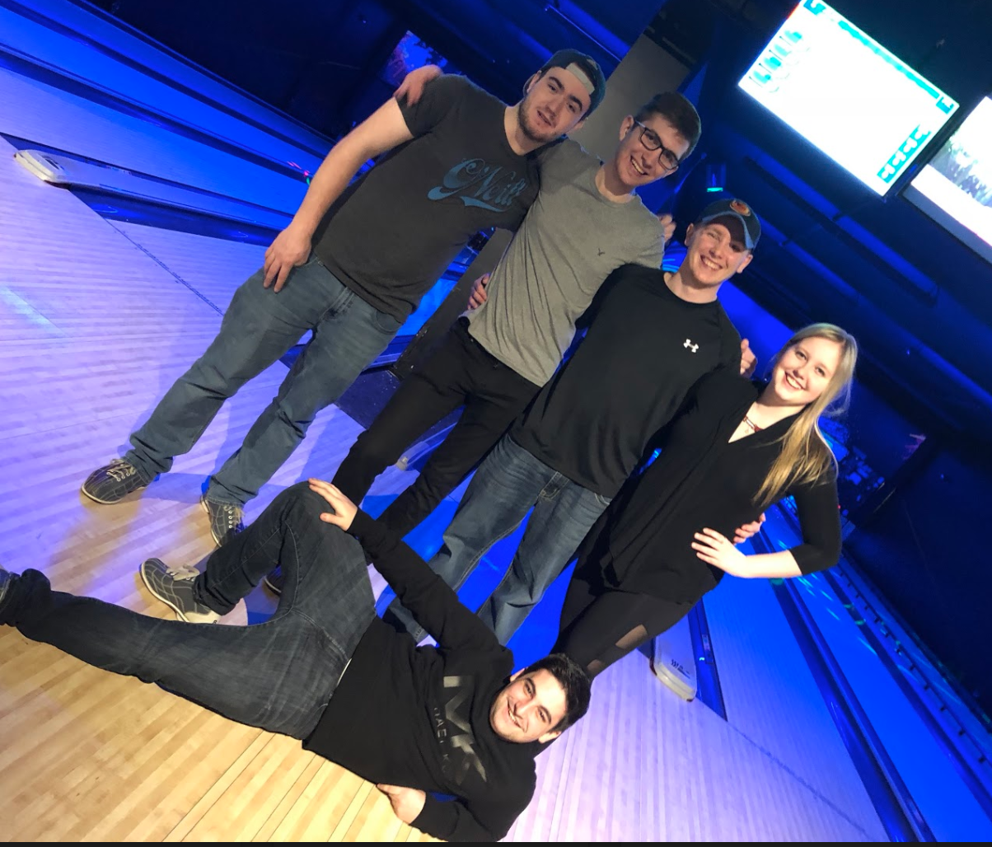

Appendix H 4

Appendix I 1

Appendix I 2

Appendix I 3

Appendix I 4

Appendix I 5

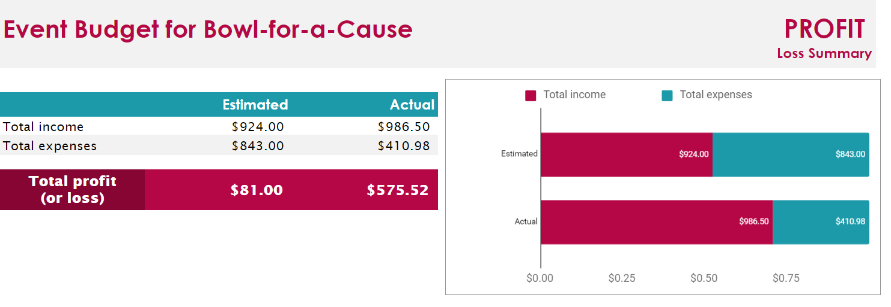
Appendix J 1
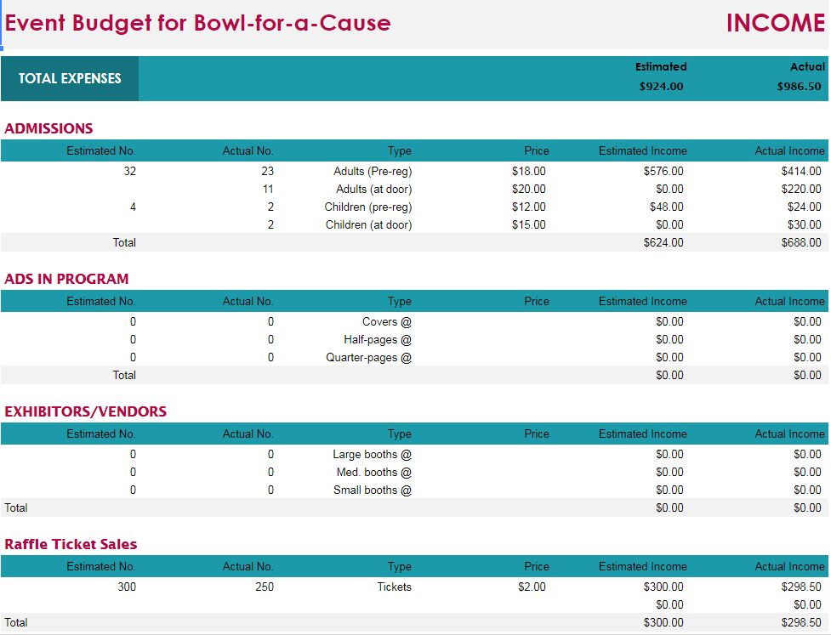
Appendix J 2

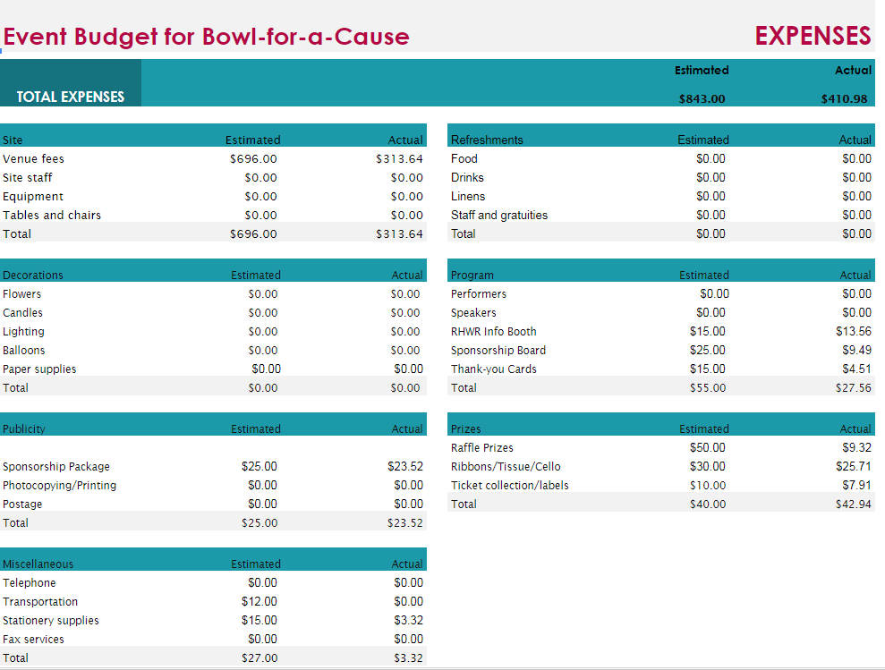

Appendix J 3

