TD Kitchener-Waterloo’s Blues Festival 2017
Hannah Charlton
7503303
Advertising, Marketing and Branding
Bernie Gauthier, PhD
March 16, 2017

The Beginning.
The City of Kitchener has been hosting the TD Bank Kitchener-Waterloo Blues Festival for 17 years this August. This long-time tradition brings a crowd from across Canada, which give the festival the reputation for ‘largest blues festival in Canada.’ On the first night of the three-day festival, the first night, the Thursday night, of the festival, patrons must buy tickets to see the first set of shows. For the last two days of the festival, admission is free. This is an all ages show, there are designated beer tents and areas where you could stand and drink and watch the main stage that sits on King Street in front of Kitchener City hall. There is a second stage down the street in Victoria Park near the Bell Tower. If you were at one stage, you could hear the other stage.
Even though the festival is only three days long, the marketing and advertising starts in September. The search for volunteers started in January and the pitches for musical line ups started the first night of the festival, by inviting any acts that were already playing that year and seeing if they would come back for the following year. Planning ‘Canada’s largest blues fest’ takes a lot work and a lot of parts to keep up the reputation that they have built.
To the public eyes, the start of the advertising campaign, the public gather at Wax Nightclub in Kitchener where the lineups for each stage and the announcements of performers are released. This is also a chance for volunteers from passed shows and the upcoming shows to mingle and to get to know each other.
Having the lineup and set launch party at the Wax Nightclub brings more parts of the Kitchener scene into the festival even if it does not start until August. It starts the anticipation that the patrons that went last year, come back for another year. The launch party also is the starting point of the media release. “The media isn’t allowed to know until an hour after the launch party. It keeps the audience on their heels and makes them keep guessing” (D. Moore, Promotions Coordinator, 2017). This ‘teaser’ keeps the audience engaged. Anyone new that moved to the Kitchener-Waterloo area that has not heard of the Blues Fest before will be able to see what makes Kitchener interesting and different from other cities in the area.
After the launch party, the city starts letting the rest of the area that did not go to the launch party know who is playing and letting people know that the event is coming up soon. For the 2016 season, last year was the start of the LRT construction on that part of King street and the city was getting complaints about the construction making it harder for loyal customers to come shop local, the city and the festival planning team decided that the construction near city hall would be done by the time the stage had to be set up for the festival. The planning team also decided that the theme for the festival this year would embrace the LRT construction. Thus, came the theme slogan, “Diggin’ the Blues” (See A2). This turned the negative impact that the LRT construction into a positive media outlook. Having the two made a good image for the City of Kitchener and the festival itself.

Advertising.
The festival’s advertising, as it got closer to the date, started off small and then got to be every where people seemed to go. For the past 16 the city has used flags on the streetlights in Downtown Kitchener on King, Queen and Kitchener street. They would be placed up after the launch party which has always been on April 13 (see A1).
After the launch party, the festival’s Facebook and Twitter page (see A4), will release the list of headlining performers playing and will release the theme of that year’s festival. The online platforms for their advertising updates anytime a new band is added to the three-day set list or if the city has any news or updates that relate to the festival.
During the beginning of May, posters for the festival will be put up in every bar (see A3), and radio station in the Kitchener-Waterloo area. Sponsors will be announced now and the festival’s posters will have the platinum sponsors on the posters. Radio ads will start now on any radio station that covers the K-W area, Cambridge, London, and the surrounding area. These radio stations would be chosen on the music that they mainly play. For example, 107.5 Dave FM will play their ads for the months of May to the last day of the festival on the Saturday. 105.3 Virgin Radio however will not play ads until July because the station is more focused on playing the greatest number one pop music hits. They do play the ads because Virgin Radio is considered Kitchener’s radio station.
During the early weeks of August, The Morning Buzz of Dave Fm, will start a contest to win backstage passes or exclusive merch from the festival. During the afternoon, The Craig Fee Show, who has his own trivia contest is another way to when free beer tickets or back stage passes. Dave FM is a sponsor that is on scene at the festival.
The radio advertisements get the most audience coverage because of a few reasons. The radio stations cover more area that the posters do. The radio stations play the same genre of music that will be playing at the festival. Blues music is the ground work of rock and punk music. If the audience likes rock music, they will like what is playing at the Blues Festival.
Television ads start at the beginning of August. TV stations like CTV and Global, will play short 30 second ads that will play during commercial breaks. The most common air time that these ads will play would be during commercial breaks for the CTV Kitchener news at six pm and CTV Toronto news at eleven pm.

The Audience.
When looking at the demographic and audience that the festival is trying to reach, it festival is trying to reach rock and blues music listeners of any age. They are trying to build a loyal customer base and relationship with customers that will come back each year, regardless of the different performers each year. The festival keeps the customers happy by doing a couple things. They keep police presence to a minimal but just enough so that if there are problems, there is someone there to help resolve it. It also let’s the Waterloo Regional police engaged in what is going on in the city.
The audience also looks for good beer to drink as they are watching the stage. The festival has designated spots were alcohol is allowed. They are very hard and strict when it comes to minors trying to sneak into those areas. They give out wristbands that say you are allowed in. When buying beer tickets, they check your ID before entre and at the table. These rules must be in place because not only will serving an underage minor liquor look bad for the City and the festival coordinators, but it is against the law. They have bent some of the liquor laws like open containers on public streets however, the alcohol is not allowed to leave the areas that was the designated alcohol areas. That sense of willing to bend the rules and allow the liquor to be served to a mass amount of people, is the trust the City has for the people that they are not going to do anything that will jeopardise the festivals liquor licence.
The alcohol itself is what the audience looks for. The tickets sales are what keeps the two days of the festival free admission. If the alcohol is poor quality, sales will go down, which means admissions will by put into place. The festival will place orders from beer and liquor stores across the K-W area so it stays local.
The Festival sticks with Canadian brands like Canadian, Cools Light and Moosehead. They offer tall boys for the people that take their time when drinking a beer. They also offer Clamato’s, and two flavors of Palm Bay’s for mostly younger to middle age women and non-beer drinkers. Red, white and a rose wine is offered for any one that prefers wine over beer and vodka based drinks.
This keeps the audience and target market open to all genders, legal ages, education and life cycle demographic profiles. When the behavioural profile is analysed, ticket buyers will either do one of two things, they will either buy one ticket at a time every time they want a drink, or they will buy enough tickets that will last them all day. This is interesting because it can show who is trying to save money or has the money to spend.
The festival relies on second-order branding more than first-order branding. It is the personal experience that will draw the customers back for the next year and the year after that. The first-order branding will get their attention and the information that will get them there, however, if they have a good experience with the performance, the crowd around them, the vendors and alcohol and the atmosphere that will bring them back. The more relaxed and entertained the customer feels, the odds of them coming back next year with more friends and family will be high.

Volunteers
The volunteers are what makes the Festival run so smoothly. They are stage hands, ticket sellers, bartenders, and clean up crew. Volunteer Coordinator, Joe C, (requested to keep his last name out), sends out emails all year round to his volunteers. He keeps them updated on events like the launch party and the volunteer’s appreciation party at Bobby O’Brien’s after the festival. He makes sure that there is enough people in the right spots and will move people if there’s not enough.
The volunteers are an unofficial advertising and marketing strategy that the festival has. The volunteer’s will tell their family, friends and co-workers that they are volunteering their time at the Blues Festival and that they should come along. This word of mouth will travel to person to person which is a great form of unpaid advertising.
At the Volunteer Appreciation party, Bobby O’Brien’s offers the volunteer’s free food and drinks donated by the pub. By offering the free food, the volunteer’s will come back as volunteer’s the following years. This will also create customer loyalty so the festival can count on having approximately the same amount of volunteer’s and they will not have to struggle looking for volunteers for the next years.
Joe has set up the scheduling and jobs that are needing people online, so all volunteer’s must do is register, pick what job they want and what time they can be there. “If the volunteer’s pick the time then the more likely they’ll come for their shift. We want them to feel like they want them to be there, not forced” (J. C, Volunteer Coordinator, 2017).
The Festival offers their volunteers free food passes which helps them get through the day whenever they get a break. This is a chance for the volunteers to try different food vendors that the festivals offer. If the volunteers are treated right, then the Festival will continue to run smoothly.

Conclusion.
This marketing campaign is very effective and integrated. It has a wide range of different advertising vehicles from print, online ads, radio and television. It also has unpaid advertising opportunities from word of mouth from the volunteers and the customers and other online blogs. This marketing plan is timed through out the year that starts after the Volunteer Appreciation party in September and lasts until the last day of the Festival. The different ads are timed as the Festival dates get closer and the closer the time get’s, the more ads get released. The ads are placed on purpose where the audience will see or hear it (bars and rock radio stations). The plan takes in account what demographic it is trying to reach and made it family friendly. Sponsors were made publicly known and involved in the Festival. They stayed local when it came to party locations and festival location, making Downtown Kitchener and Kitchener City hall welcoming for patrons.
This long-time tradition will forever have a home in Kitchener and it will be a part of Kitchener’s history if good music is being containing to be made.

Appendix.
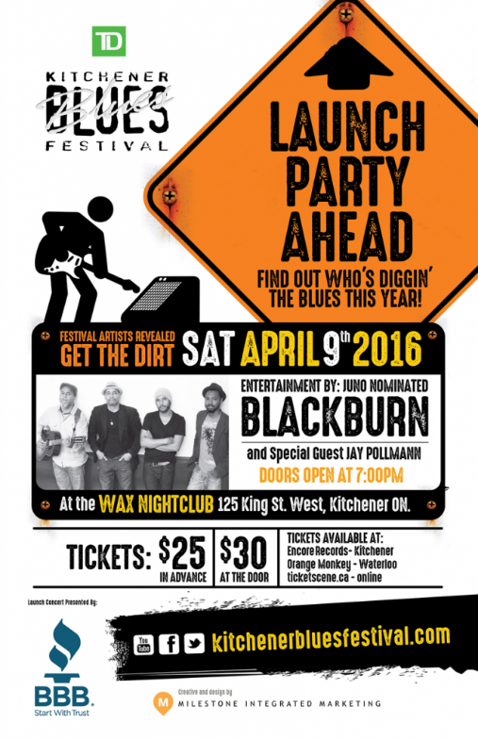
A1: The first wave of advertising is for the launch party at the Wax Nightclub.

A2: The poster ad for the Youth Showcase that will have the winner play on the Main stage.
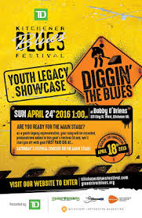
A3: Poster ad for the kick-off show for the first night of the Festival
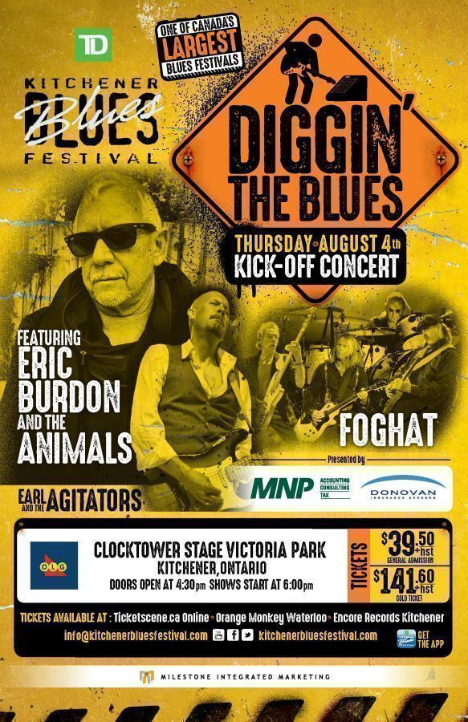
A4: This is the web headliner for the Blues Festival website
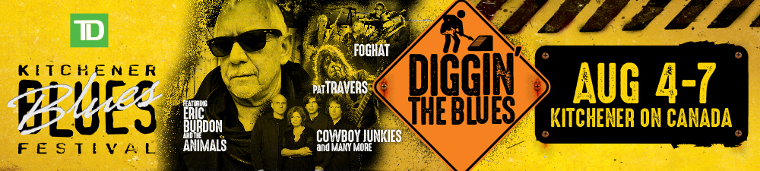

References.
D, M. Promotions of The Blues Festival 2016 [Personal interview]. (2017, March 1).
C, J. (2017, March 7). Volunteer Coordinator's Duties [E-mail to the author].
Cowboy Junkies, Eric Burdon, Big Sugar part of Kitchener Blues Festival lineup. (2016, April 9). Retrieved March 13, 2017, from
http://www.cbc.ca/news/canada/kitchener-waterloo/cowboy-junkies-eric-burdon-big-sugar-part-of-kitchener-blues-festival-lineup-1.3527407
Ticketscene. (n.d.). TD Kitchener Blues Festival Kick-off Show [Digital image]. Retrieved March 15, 2017, from
https://www.google.ca/search?q=kitchener blues festival 2016 different advertising&rlz=1C1CHBF_enCA721CA721&espv=2&source=lnms&tbm=isch&sa=X&ved=0ahUKEwj76MC-lNnSAhUL4oMKHeziDUYQ_AUIBygC&biw=691&bih=563#imgrc=y9Td3_ezYr6CBM:
Milestone Integrated Marketing. (n.d.). TD Kitchener Blues Festival Launch Party [Digital image]. Retrieved March 15, 2017, from
http://www.kitchenerbluesfestival.com/more-events/td-kitchener-blues-festival-launch-party/
Hamilton Blues Lovers. (2016, April 29). Kitchener Blues Festival Youth Legacy Showcase [Digital image]. Retrieved March 15, 2017, from
http://blueshamilton.blogspot.ca/2016/04/congrats-spencer-mackenzie-band-wins.html
Kitchener Blues Festival. (n.d.). TD Kitchener Blues Festival Webheader 2016 [Digital image]. Retrieved March 15, 2017, from
https://www.google.ca/search?q=the blues festival 2016&rlz=1C1CHBF_enCA721CA721&espv=2&source=lnms&tbm=isch&sa=X&ved=0ahUKEwj2kKTzk9nSAhUMw4MKHfzuCZcQ_AUIBygC&biw=691&bih=612#tbm=isch&q=the kitchener blues festival 2016&*&imgrc=rUdPEXlcfk_kRM:

