Lindsay Harant, Hannah Charlton
7729981, 7503303
Conestoga College
PRLN72010
Assignment 3: Netflix
Prof. B. Gauthier
April 25, 2018

SECTION 2 – CREATIVE STRATEGY
1 | We require  (Check all that apply) | ☐ | Newspaper Ad | ☐ | Magazine Ad | ☐ | Other Print Ad
1 | We require  (Check all that apply) | ☐ | Newsletter | X | Poster | ☐ | Insert
1 | We require  (Check all that apply) | ☐ | Brochure | ☐ | Article | ☐ | Invitation
1 | We require  (Check all that apply) | X | Web Content | X | Banner Ad | ☐ | Email
1 | We require  (Check all that apply) | ☐ | Signage | ☐ | Office Support (PPT) | X | Social Media Posts
1 | We require  (Check all that apply) | ☐ | Other:
2 | Background  The product or service; The R&D; The market | Netflix began over 20 years ago in 1997. Back then, it was a DVD rental service but over the years has progressed into one of the biggest and most popular streaming subscriptions in the world. In 2018, Netflix is planning on spending roughly 8 million dollars on original content, “Netflix Originals”, in order to bulk up their library. Their goal is to have half of their content be Netflix Original shows and movies due to the fact that 37% of people who subscribe to Netflix use it solely to watch Netflix Originals. Our market includes those who frequently use social media sites, as well as those who are currently Netflix subscribers rather than those who have not yet jumped onto the Netflix bandwagon. This is because Netflix already has a massive audience of over 100 million users - and that number just keeps on growing. We want to better advertise their Netflix Original options from comedies, to cooking shows, to family friendly content, and everything in between. This audience sounds large but the reality is, 72% of Millennials, 73% of Gen X-ers, 67% of Boomers, and 56% of Retirees already use Netflix and despite the fact that younger generations are most closely tied to social media usage, the reality is that 45 million Facebook users are those between ages 55 and 65.
3 | Positioning Statement  How are we different from and superior to the competition? What one strategic quality do we want the audience to remember? | Normally when Netflix launches a new show or movie, or releases a new season of a said show, there isn’t much advertisement that goes into it beyond the online sphere. As of right now, word of mouth tends to make or break new Netflix content. We want to step away from this and create our own web based content to promote the latest and greatest from Netflix, rather than relying on written articles and word of mouth. Our advertisements will be a collection of sponsored social media advertisements and printable posters that will be used to promote Netflix Original shows and movies. Right now, Netflix is like other subscription based television companies such as Hulu and Crave in the sense that they just aren’t putting that much out there in terms of advertisements. We want to break Netflix away from this to gain more viewers who are interested in Netflix Originals.
4 | Communication Objective(s)  What change in awareness, motivation, action and relationship are we trying to bring about? With whom? | Netflix creates original content that appeals to people of all ages and interests. Not only do they have their own comedies, cooking shows, and documentaries, but they also have a range of family friendly content that can be enjoyed by the youngest of Netflix viewers. Many people use Netflix to binge watch their old favourites like Friends and occasionally dabble in the original content that Netflix has to offer. We want to increase the number of people watching Netflix Originals because these will eventually comprise 50% of their entire catalogue. Netflix Original shows have garnered a reputation for talking about real subjects that real people deal with in their own lives, and they’ve been praised for the realism that they bring to TV. What we want to do is make people aware of this and make them want to choose shows that provide them with characters that they can get realistically attached to over shows that fall flat in facts, real life depiction, and character growth.
5 | Target Audience  Actors? Influencers? Enablers? What do we know about them? | Primary: Some major influencers that Netflix has already used are major names in Hollywood such as Selena Gomez, Nick Kroll, Amy Schumer, Jane Fonda, and Lily Tomlin - just to name a few. This is a major advantage because people of all ages and of all interests can access their favourite comedians and actors in one place, all we have to do now is convince people to watch their original content.
5 |  | Secondary:
6 | Call to Action  What do we want them to believe or do as a result of the communication? | We want audiences to recognize that Netflix has so much new and innovative content to offer that they do not need to seek shows or movies anywhere else. As a result, we want them to watch and enjoy Netflix Originals by themselves, with their significant others, and with their families.
7 | Benefit Statement  What (one thing) can we convey about the product/service that will achieve this? | Netflix has produced shows and movies of all categories, keeping in mind the interests that their users may have from comedies, to documentaries, to cooking shows, to horror. Users can go onto Netflix, search a genre that they want to watch, and select from a variety of original content.
8 | Support for Benefit  Why should they believe this? What evidence do we have? | The evidence we have are the various lists of originally produced content that are available on Netflix itself, as well as a multitude of websites that keeps Netflix in their headlines. Our advertisements are going to be used to further communicate this but all original shows and movies are easily identifiable with the iconic “Netflix” logo available on promotional posters.
9 | Brand Attributes/Personality  If our brand were a person, who would it be? How would we be described? | If Netflix was a person, it would be the cool high school teacher that teaches you more than just the subject you go to them for. They’re cool, fun, inclusive, knowledgeable about all subjects, and everyone wants to have them as their teacher.
10 | Executional Considerations  What should we know now about how the project needs to unfold in the long run? | We need to appeal to all audiences and get their attention, and social media is the way to do this. Not only will we be able to have fun and get creative with our ads but Facebook in particular is ideal to do this because of the diverse audience that they hold - similar to that of Netflix. We need to make people realize that Netflix is revolutionary not only in their content but also the ways in which they are going about it. They’re self sufficient in that they know what they want, they know what their audiences want to see, and they aren’t waiting around for other outlets to produce the content that they strive to put into the world. They’re making it themselves and are flourishing because of it. We want the public to know that they, Netflix, are all inclusive and don’t stray away from the hard topics. And, finally, we want our advertisements to stick out by being light, humourous, and memorable.
The Advertisements
1. Video
Our video advertisement will open with a family gathered around a television set. They want to watch a movie but the DVDs that they have are either inappropriate for children, or they’ve already watched them all countless times. We know that it’s raining outside due to the weather forecast playing on the television in the background. They all start bickering because they cannot decide what to watch and just then, a commercial appears on the screen for Netflix. The family starts to pay attention as hundreds of titles flash across the screen, advertising Netflix Originals. The titles and images go from cooking, to mystery, to documentaries, and finally to family friendly shows and movies. They all start to smile and nod in agreement at the fact that they should create a Netflix profile. The video closes with them watching a Netflix movie; “Netflix Original” appears on the screen as the video fades away.
2. Poster #1 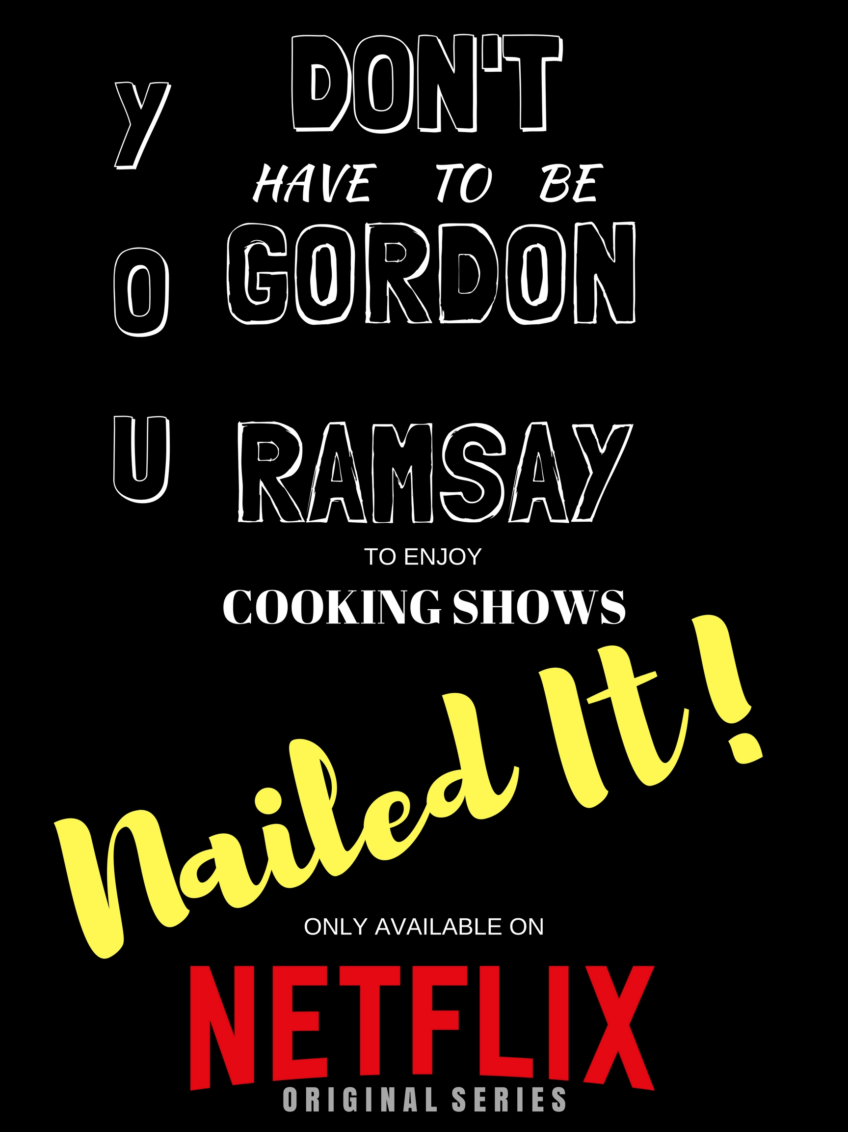

3. Facebook Banner

This Facebook banner is what people will see when they see Netflix’s Facebook page.
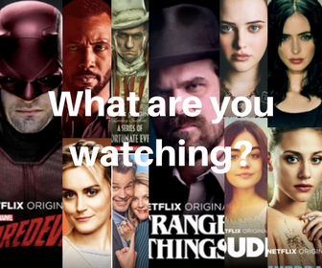
References
Gilliland, Nikki. (August 18, 2017). Five examples of brands that succeed with
word-of-mouth marketing. Retrieved April 21, from
https://www.econsultancy.com/blog/69348-five-examples-of-brands-that-suc
ceed-with-word-of-mouth-marketing
Leong, Benjamin. (February 2, 2016). How Netflix Achieved A 70 Million Subscriber Rate -
Through Word-of-Mouth. Retrieved April 19, from
https://www.referralcandy.com/blog/netflix-marketing-strategy/
Rodriguez, Ashley. (July 17, 2017). Netflix has more than 100 million subscribers - and it’s
burning a lot of cash to keep hold of them. Retrieved April 20, from
https://qz.com/1031510/13-reasons-why-and-orange-is-the-new-black-are-dig
ging-netflix-out-of-its-second-quarter-subscriber-slump/
Statista. (2018). Number of Facebook users by age in the U.S. as of January 2018 (in
millions). Retrieved April 20, from
https://www.statista.com/statistics/398136/us-facebook-user-age-groups/
Statista. (2018). Share of consumers with an active Netflix subscription in the United
States as of February 2017, by age group. Retrieved April 20, from https://www.statista.com/statistics/698020/netflix-subscription-by-age/

