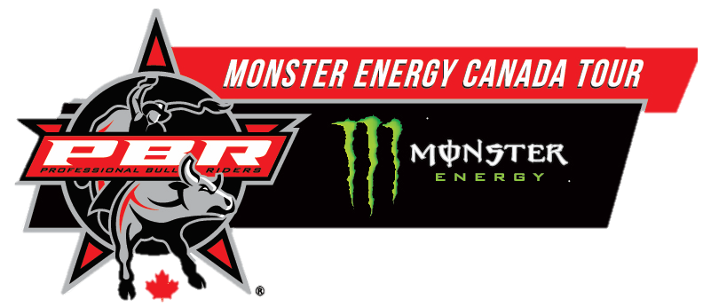
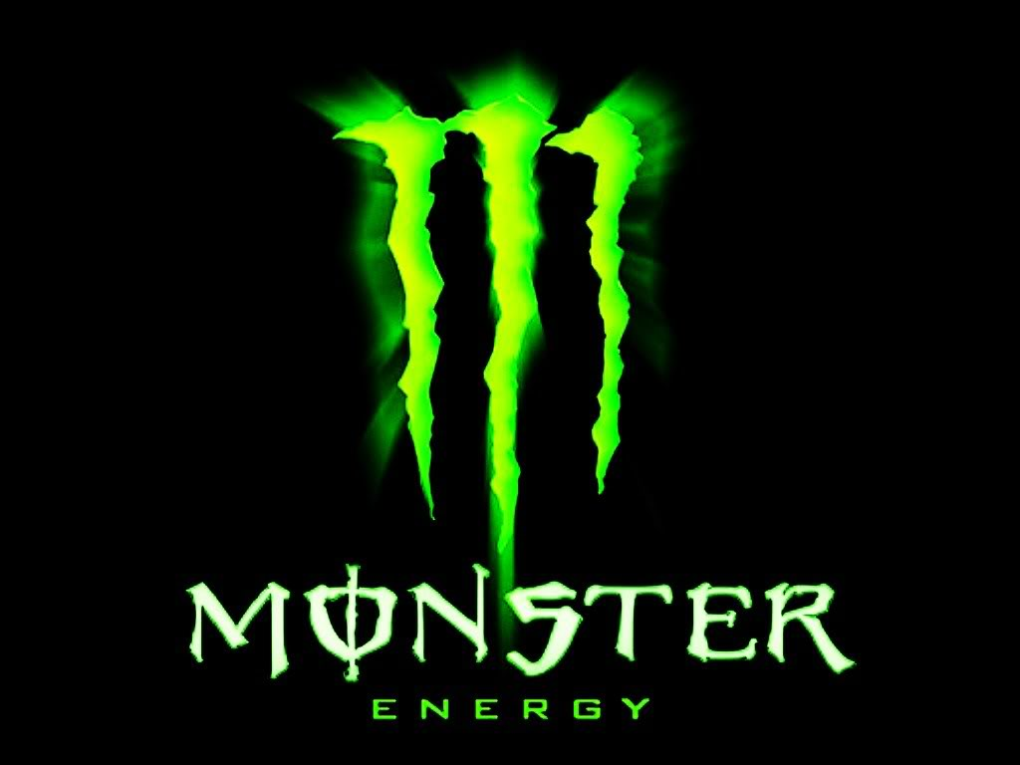

PBR is Back and Ready to Kick Some Ass.

Written by: Hannah Charlton
The Professional Bull Riders Monster Energy Tour is back for the 2017 season for the second year, which include 8 stops across Canada starting with the Canadian Qualifier at Rexall Place in Edmonton.
Riders across Canada and the US have joined us for this year’s tour starting 2017-06-02 thru to 2017-11-09.
Locations include: Centre Videotron: Quebec City, QC, TD Place: Ottawa, ON, Ricoh Coliseum: Toronto, ON, Bell MTS Centre: Winnipeg, Manitoba, Abbotsford Centre: Abbotsford BC, Sasktel Centre: Saskatoon, SK, Rexall Place: Edmonton, Alberta.
To purchase tickets, you can head to the Official Monster Energy Website PBR event page.


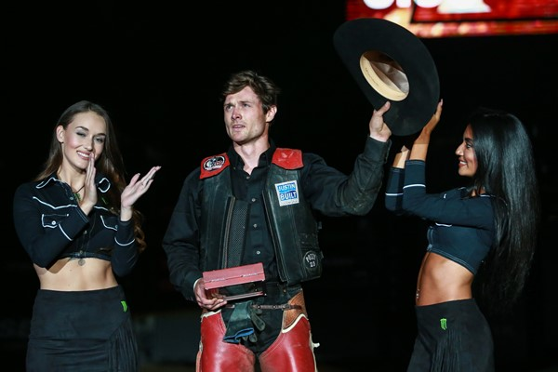
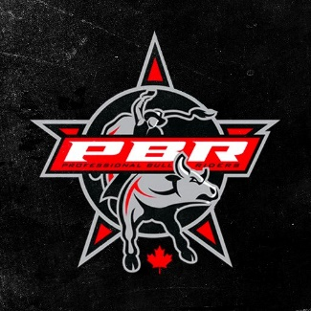
Published: 2017-05-02

