Burger King’s Whopper Net Neutrality
Hannah Charlton
7503303
Specialized Writing III
Bernard Gauthier
April 10, 2018

Section 2 – CREATIVE STRATEGY
1 | We require  (Check all that apply) |  | Newspaper Ad |  | Magazine Ad |  | Other Print Ad
1 | We require  (Check all that apply) |  | Newsletter |  | Poster |  | Insert
1 | We require  (Check all that apply) |  | Brochure |  | Article |  | Invitation
1 | We require  (Check all that apply) |  | Web Content |  | Banner Ad |  | Email
1 | We require  (Check all that apply) |  | Signage |  | Office Support (PPT) |  | Social Media Posts
1 | We require  (Check all that apply) |  | Other:
2 | Background  The product or service; The R&D; The market | With the threat of net neutrality being at risk in the States, it is a concept that not a lot of people understand. It can be complicated to understand with the jargon and language people use to explain it. The commercial uses the example of Burger Kings popular menu item the Whopper as a metaphor for net neutrality and what would happen if it got voted to not be renewed.  In the ad customers getting upset that other people (played by actors) are getting their burgers first even though they ordered them after him. It is then explained to them that on their menu they have these passes that will cost the customer 5-25$ more just for the speed in order to make the burger (figure 2), (Reilly, K. (2018, January 25).
3 | Positioning Statement  How are we different from and superior to the competition? What one strategic quality do we want the audience to remember? | This topic is normally ignored and is changed so people don’t understand what it really means if the net neutrality. No one is talking about it. Whoppers are considered America’s favourite burger. The States is being split in two in the choice to renew the bill. With enough votes that they can get the message to, the greater chance of the bill being renewed. With the fan base the Whopper has created, they have a large influence factor in the public.
4 | Communication Objective(s)  What change in awareness, motivation, action and relationship are we trying to bring about? With whom? | The main objective is getting the meaning across about the failure to renew the bill for net neutrality. In the video ad, it shows Burger King employees charging customers extra money for different speeds of their burgers being made; the more they pay, the faster they get their food item. If customers are getting upset of the extra money just for the speed to make it, they will be the same way for the use of the internet. They are trying to reach everyone that they can because the matter is going to affect everyone that uses the internet and popular websites/ social media sites. “The repeal of Net Neutrality is a hot topic in America, nut it can be very difficult to understand. That’s why the Burger King brand created Whopper Neutrality, a social experiment that explains the effects of the repeal of Net Neutrality by putting it in terms anyone can understand: A Whopper sandwich,” Reilly, K. (2018, January 25). There is a petition on Change.org for people to sign their name in support for the renewal for the bill.
5 | Target Audience  Actors? Influencers? Enablers? What do we know about them? | Primary: Adults (men and women) who can vote. This is a large audience, however, the larger the audience, the more effective their votes and voices will be on the matter. Net neutrality effects everyone so everyone should be involved. Without their votes, they are telling the government that they are willing to pay for the speed of the internet and have to pay to use every single website that they visit. The more voters that Burger King can get to truly understand what that means, the more likely they will pressure Congress to renew the bill.
5 |  | Secondary: This would be the politicians and internet companies. By hearing what the voters have to say and see their reaction when it comes to making a simple Whopper, they will renew the bill without the primary audience being completely outraged. Politian’s will listen to their publics when they feel like their position is at risk.
6 | Call to Action  What do we want them to believe or do as a result of the communication? | We want them to realize what is going to happen if the bill is not going to be renewed. We want them to know what net neutrality is and what it means. We want people to take action and vote for the bill to be renewed again.
7 | Benefit Statement  What (one thing) can we convey about the product/service that will achieve this? | Having the Whopper serve as a metaphor which is a popular fast food product, it makes the message and the idea behind Net Neutrality easier to understand. If people are being out raged by how much their fast food costs, imagine how upset they’ll be about how much it will cost just to use Facebook.
8 | Support for Benefit  Why should they believe this? What evidence do we have? | The FCC (the Federal Communications Commission) has voted to repeal the net neutrality rules for internet providers. This allows internet providers to legally slow down websites, block apps and charge content extra fees before giving access to customers (Fung. B. (2018, February 22).
9 | Brand Attributes/Personality  If our brand were a person, who would it be? How would we be described? | John Oliver from the Last Week Tonight show on HBO. This ad is honest, ‘in your face’ and it makes people angry with the truth. John Oliver also explains complicated topics that can be hard to understand and voices his opinion on the matter. He talks about controversial topics and makes his audience aware of what they need to know.
10 | Executional Considerations  What should we know now about how the project needs to unfold in the long run? | Burger King will have to keep up to date with what is happening with the bill. The ads should be circulating until some change has happened and the bill has been renewed. This topic will be an on-going problem until it either passes or not.

Appendix
Figure 1:
https://www.youtube.com/watch?v=ltzy5vRmN8Q

Figure 2:
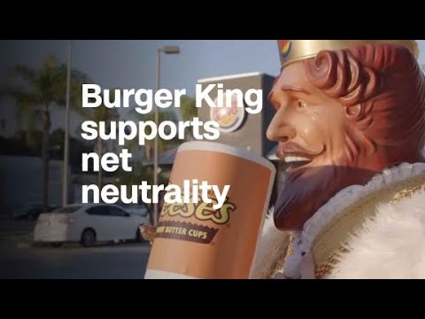
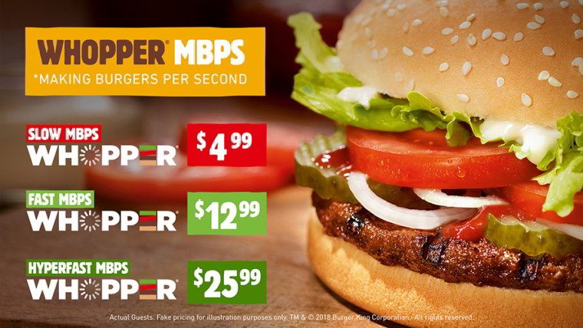
Figure 3:

Figure 4:
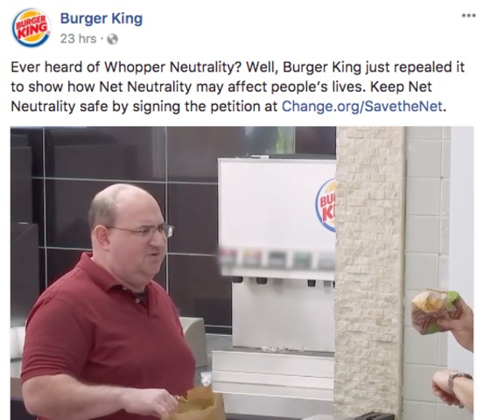
Figure 5:
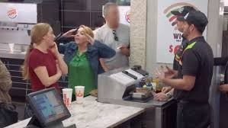
Figure 6:
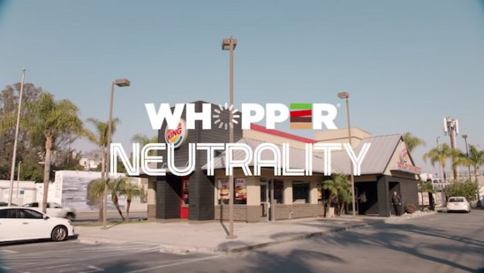

References
Reilly, K. (2018, January 25). Burger King Whopper Ad Explains Net Neutrality. Retrieved April 10, 2018 from
http://time.com/5117628/burger-king-whopper-net-neutrality-ad/
Oliver, J. [LastWeekTonight]. (2014, June 1). Net Neutrality: Last Week Tonight with John Oliver (HBO) [Video File]. Retrieved April 10, 2018 from
https://www.youtube.com/watch?v=fpbOEoRrHyU
Oliver, J. [LastWeekTonight]. (2017, May 7). Net Neutrality: Last Week Tonight with John Oliver II (HBO) [Video File]. Retrieved April 10, 2018, from
https://www.youtube.com/watch?v=92vuuZt7wak
Burger King. [BURGER KING]. (2018, January 24). Burger King Whopper Neutrality [Video File]. Retrieved April 10, 2018, from
https://www.youtube.com/watch?v=ltzy5vRmN8Q
Fung. B. (2018, February 22). The FCC’s vote repealing its net neutrality rules is finally official. Here’s what happens now. Retrieved April 10, 2018, from
https://www.washingtonpost.com/news/the-switch/wp/2018/02/22/the-fccs-net-neutrality-rules-will-die-on-april-23-heres-what-happens-now/?noredirect=on&utm_term=.3224f23bcf72

